**Year 11 into Year 12 Summer holiday homework booklet** 

The tasks in this booklet will help you to prepare for the aptitude test that you will sit when you return, It is split into two sections

Section A Coasts

Section B Regeneration

In each section you will find

* a checklist of everything you need to know for that topic
* Articles and text books extract for you to read, summarise
* A space for you to write questions about the material that you are reading about and engaging with
* Some example questions that you could be asked about the text that you have read

Good Luck and we look forward to seeing you in September

**SECTION A - Coasts**

**A Level Geography**

**Specification and PLC (Personal Learning Checklist)**

**AREA OF STUDY: 1: Dynamic Landscapes Topic 2B: Coastal Landscapes and Change Autumn Y12**

**Overview:**

Coastal landscapes develop due to the interaction of winds, waves and currents, as well as through the contribution of both terrestrial and offshore sources of sediment. These flows of energy and variations in sediment budgets interact with the prevailing geological and lithological characteristics of the coast to operate as coastal systems and produce distinctive coastal landscapes, including those in rocky, sandy and estuarine coastlines. These landscapes are increasingly threatened from physical processes and human activities, and there is a need for holistic and sustainable management of these areas in all the world’s coasts. Study must include examples of landscapes from inside and outside the UK.

|  |  |  |  |  |
| --- | --- | --- | --- | --- |
| **What do I need to know?** | | | | |
| **Enquiry question 1: Why are coastal landscapes different and what processes cause these differences?** | | | | |
| Key Idea | Detailed content | **PLC** | | |
| **RED** | **AMBER** | **GREEN** |
| 2B.1 The coast, and wider littoral zone, has distinctive features and landscapes. | a. Define (and locate) littoral zone, backshore, nearshore and offshore zone. |  |  |  |
| b. Understand the littoral zone includes a range of coastal types and is a dynamic zone of rapid change. |  |  |  |
| c. Understand how coasts can be classified by using longer term criteria such as geology and changes of sea level or shorter term processes such as inputs from rivers, waves and tides. |  |  |  |
| d. Describe characteristics of rocky coasts (high and low relief) result from resistant geology (to the erosive forces of sea, rain and wind), often in a high-energy environment. |  |  |  |
| e. Describe characteristics of coastal plains (sandy and estuarine coasts) found near areas of low relief and result from supply of sediment from different terrestrial and offshore sources, often in a low-energy environment. |  |  |  |
| 2B.2 Geological structure influences the development of coastal landscapes at a variety of scales | a. Explain how geological structure is responsible for the formation of concordant and discordant coasts. |  |  |  |
| b. Explain how geological structure influences coastal morphology (Dalmatian and Haff type concordant coasts and headlands and bays on discordant coasts). |  |  |  |
| c. Explain how geological structure (jointing, dip, faulting, folding) is an important influence on coastal morphology and erosion rates, and also on the formation of cliff profiles and the occurrence of micro-features, e.g. caves. |  |  |  |
| 2B.3 Rates of coastal  Recession and stability depend on lithology and other factors. | a. Understand that bedrock lithology (igneous, sedimentary, metamorphic) and unconsolidated material geology are important in understanding rates of coastal recession. |  |  |  |
| b. Explain how differential erosion of alternating strata in cliffs (permeable/impermeable, resistant/less resistant) produces complex cliff profiles and influences recession rates. |  |  |  |
| c. Explain how vegetation stabilises sandy coastlines (dune succession and marsh succession). |  |  |  |

|  |  |  |  |  |
| --- | --- | --- | --- | --- |
| **Enquiry question 2: How do characteristic coastal landforms contribute to coastal landscapes?** | | | | |
| Key Idea | Detailed content | **PLC** | | |
| **RED** | **AMBER** | **GREEN** |
| 2B.4 Marine erosion creates distinctive coastal landforms and contributes to coastal landscapes. | a. Differentiate between constructive/destructive waves. |  |  |  |
| b. Explain how wave type influences beach morphology and profiles at a variety of timescales (daily/longer periods). |  |  |  |
| c. Recall and differentiate between erosion processes (hydraulic action/ corrosion/ abrasion/ attrition). |  |  |  |
| d. Describe how erosion types are influenced by wave type, size and lithology. |  |  |  |
| e. Describe the formation of erosional landforms - wave cut notch, wave cut platform, cliffs, cave-arch-stack-stump. |  |  |  |
| 2B.5 Sediment transport and deposition create distinctive landforms and contribute to coastal landscapes. | a. Describe/Explain the process of longshore drift and how it affects sediment transport (as well as angle of wave attack, tides and currents). |  |  |  |
| b. Describe the formation of transportation and depositional landforms - beach, recurved and double spits, offshore bars, barrier beaches and bars, tombolos and cuspate forelands - which can be stabilised by vegetation succession. |  |  |  |
| c. Understand the coast as a system using the Sediment Cell concept (sources, transfers and sinks) - including negative and positive feedback - as an example of dynamic equilibrium. |  |  |  |
| 2B.6 Subaerial processes of mass  movement and weathering influence coastal landforms and contribute to coastal landscapes. | a. Define and differentiate between mechanical, chemical and biological weathering. |  |  |  |
| b. Understand why weathering is important in sediment production and influences rates of recession. |  |  |  |
| c. Define and differentiate between blockfall, rotational slumping and landslides (mass movement). |  |  |  |
| d. Understand why it is important on some weak/ complex coasts. |  |  |  |
| e. Describe the formation of mass movement landforms - rotational scars, talus scree slopes, terrace cliff profiles. |  |  |  |

|  |  |  |  |  |
| --- | --- | --- | --- | --- |
| **Enquiry question 3: How do coastal erosion and sea level change alter the physical characteristics of coastlines and increase risks?** | | | | |
| Key Idea | Detailed content | **PLC** | | |
| **RED** | **AMBER** | **GREEN** |
| 2B.7 Sea level change influences coasts on different timescales. | a. Understand eustatic and isostatic factors lead to longer term sea level change, as well as tectonics. |  |  |  |
| b. Describe the features associated with emergent coastlines (raised beaches with fossil cliffs). |  |  |  |
| c. Describe the features associated with submergent coastlines (rias, fjords and Dalmation). |  |  |  |
| d. Explain the risk to contemporary coastlines from global warming and tectonic activity. |  |  |  |
| 2B.8 Rapid coastal retreat causes threats to people at the coast. | a. Explain the physical factors (geological and marine) that lead to rapid coastal recession, as well as the human (dredging, coastal management). (See: Nile Delta, Guinea and California coastline). |  |  |  |
| b. Describe subaerial processes and their influence on the rate of coastal recession. |  |  |  |
| c. Explain the factors (short and long term) that influence the rate of coastal recession (wind direction/fetch, tides, seasons, weather systems and occurrence of storms). |  |  |  |
| 2B.9 Coastal flooding is a significant and increasing risk for some coastlines. | a. Explain (local) factors that increase flood risk on some low-lying and estuarine coasts (height, degree of subsidence, vegetation removal), as well as the risk from global sea level rise. (See: Bangladesh, the Maldives for examples). |  |  |  |
| b. Evaluate the impacts (short term) of storm surge events causing severe flooding (depressions, tropical cyclones). See: the Philippines, Bangladesh for examples). |  |  |  |
| c. Evaluate the increased risk caused by climate change (frequency and magnitude of storms, sea level rise), refer to mitigation and adaptation. |  |  |  |

|  |  |  |  |
| --- | --- | --- | --- |
| **Topic 2B: Geographical Skills (focus on quantitative skills)** |  | | |
| *Note: These skills are* ***not*** *exclusive to the topic areas under which they appear; you will need to be able to apply these skills across any suitable topic area throughout their course of study.* | **PLC** | | |
| **RED** | **AMBER** | **GREEN** |
| **GIS mapping** of the variety of coastal landscapes, both for and beyond the UK. |  |  |  |
| **Satellite interpretation** of a variety of coastlines to attempt to classify them. |  |  |  |
| **Field sketches** of contrasting coastal landscapes. |  |  |  |
| Using **measures of central tendency** to classify waves into destructive and constructive wave types. |  |  |  |
| Using **student t-test** to investigate changes in pebble size and shape along a drift  aligned beach and also across the littoral zone to above the storm beach. |  |  |  |
| **Map and aerial interpretation** of distinctive landforms indicating past of sea level  change. |  |  |  |
| **Use of GIS, aerial photos and maps** to calculate recession rates for a variety of  temporal rates (annual changes and longer-term changes). |  |  |  |
| **Interrogation of GIS** of management cells to ascertain land use values and develop cost/benefit analysis to inform the choice of coastal management strategy. |  |  |  |
| **Photo interpretation** of a range of approaches to management to assess environmental impact. |  |  |  |
| Sand dune or salt marsh **surveys** to assess the impact of succession using an **index of diversity, X² (Chi-square** to compare features of the various zones). |  |  |  |

|  |
| --- |
| **NOTES/CASE STUDIES** |

**Task 1 – Coastal processes**

Read the information below about the different coastal processes that occur along coastlines across the globe. In the space beneath create a mind map to state and explain how the following types of coastal processes operate at the beach: Abrasion, Hydraulic Action, corrosion & Longshore drift.

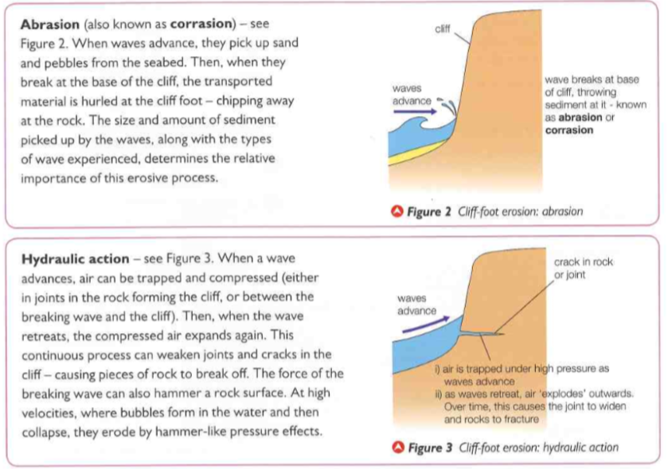

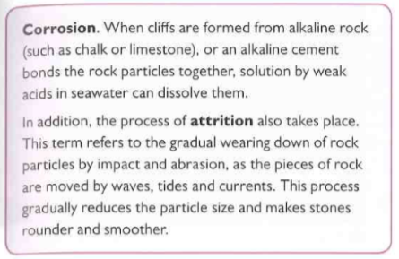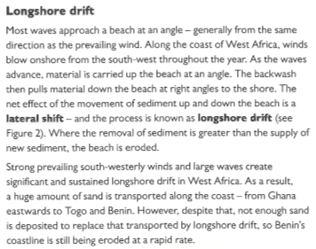

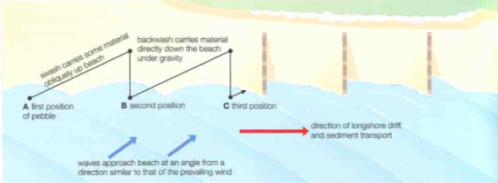

Create a mind map below to summarise the information above

**Task 2 – Concordant & discordant coastline characteristics**

Read the following information on concordant and discordant coastlines and in the table below describe the characteristics of each, using named examples as evidence for you descriptions

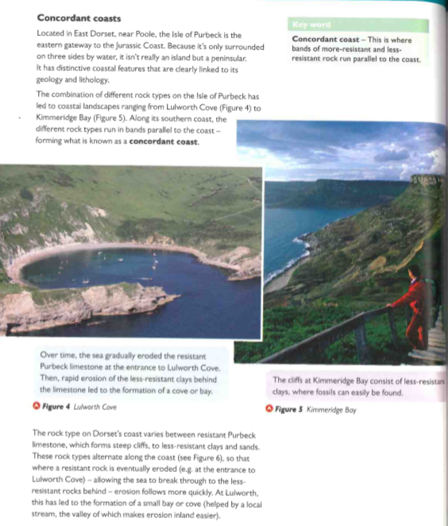

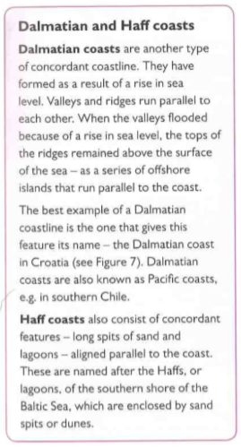 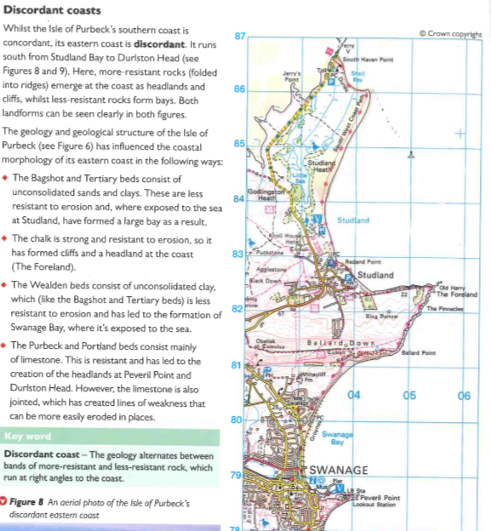

|  |  |
| --- | --- |
| Concordant coastline | Discordant coastline |
|  |  |

**Task 3 – Read the extract below and then distinguish between the pairs of terms beneath the text:**

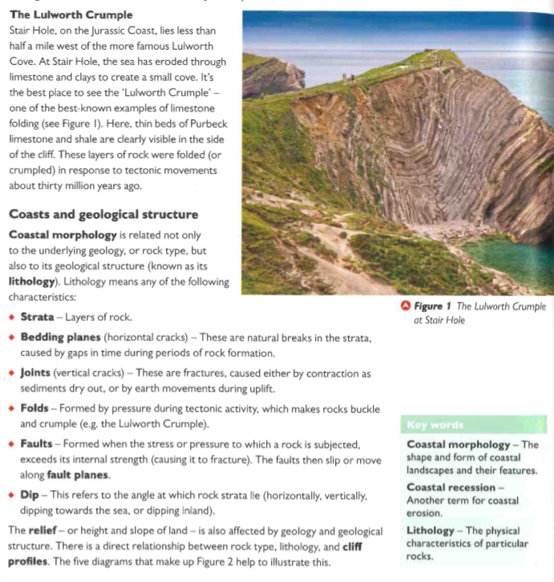

1. Geology and lithology

____________________________________________________________________________________________________________________________________________________________________________________________________________________________________________________________________________________________________________________________________________________________________________________________

1. Relief and coastal morphology

____________________________________________________________________________________________________________________________________________________________________________________________________________________________________________________________________________________________________________________________________________________________________________________________

1. Joints and bedding planes

____________________________________________________________________________________________________________________________________________________________________________________________________________________________________________________________________________________________________________________________________________________________________________________________

1. Folds and faults

____________________________________________________________________________________________________________________________________________________________________________________________________________________________________________________________________________________________________________________________________________________________________________________________

1. Strata and dip

____________________________________________________________________________________________________________________________________________________________________________________________________________________________________________________________________________________________________________________________________________________________________________________________

**Task 4 – Contemporary Vs Longer term sea level change**

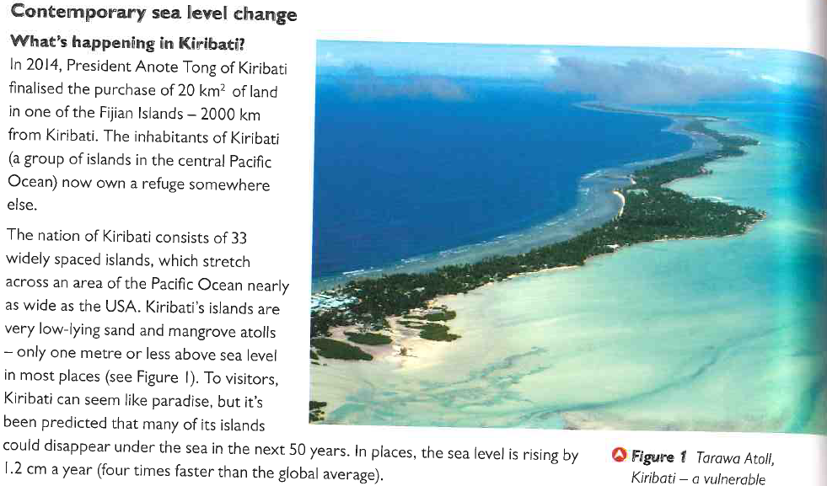

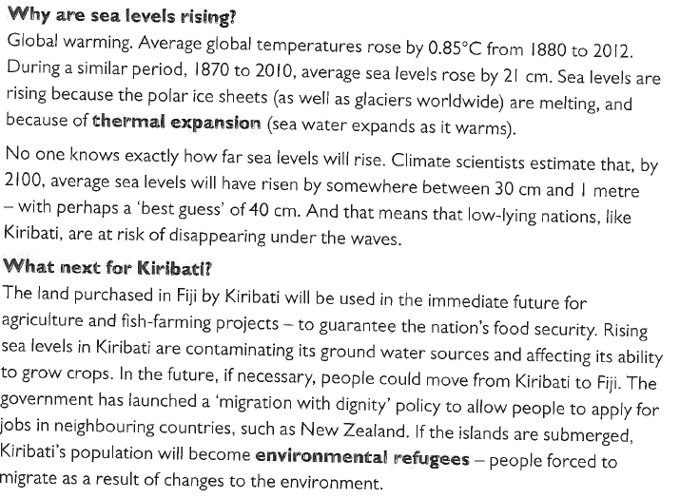

Distinguish between eustatic and isostatic change

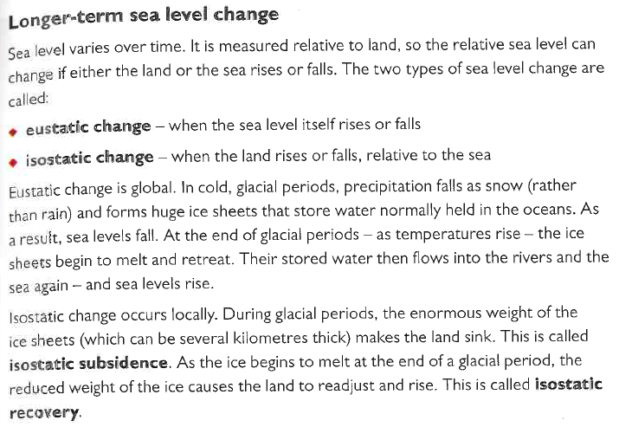

To what extent are the risk from sea level rise in the south east England (a) similar to, (b) different from the risks in Kiribati?

________________________________________________________________________________________________________________________________________________________________________________________________________________________________________________________________________________________________________________________________________________________________________________________________________________________________________________________________________________________________________________________________________________________________________________________________________________________________________________________________________________________________________________________________________________________________________________________

**Task 5 – Weathering Vs Erosion**

You have already made notes on the different types of erosion, read the information below about weathering at the coast and then assess which process has a greater role in the formation of coastal landforms (e.g. beaches, spits, bars, cliffs, wave cut platforms arches etc) weathering or erosion.

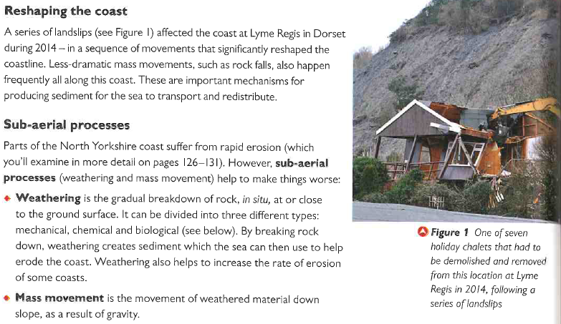

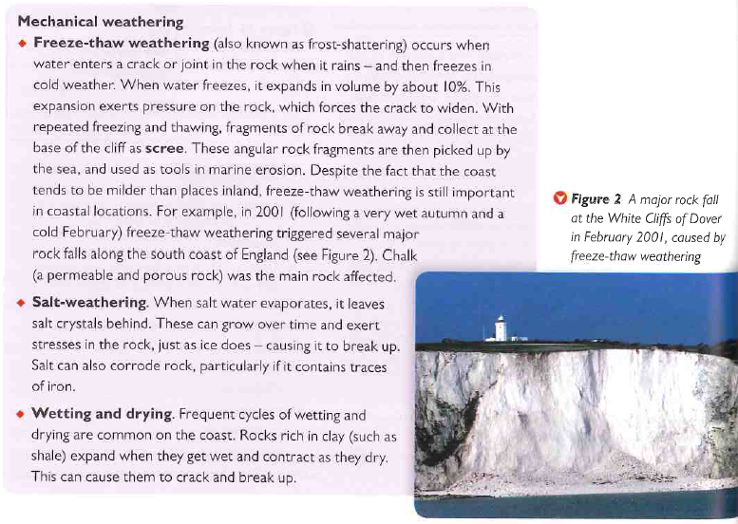

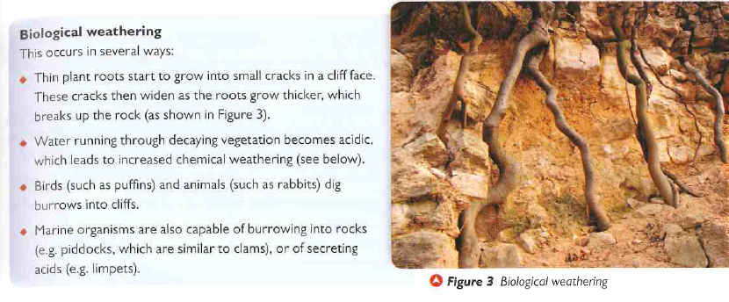

|  |
| --- |
| Assess which process has a greater role in the formation of coastal landforms (e.g. beaches, spits, bars, cliffs, wave cut platforms arches etc) weathering or erosion |
|  |

**Section B – Regenerating Places**

**A Level Geography**

**Specification and PLC (Personal Learning Checklist)**

**AREA OF STUDY: Dynamic Places Topic 4A: Regenerating Places Spring Term Y12**

**Overview:** Local places vary economically and socially with change driven by local, national and global processes. These processes include movements of people, capital, information and resources, making some places economically dynamic while other places appear to be marginalised. This creates and exacerbates considerable economic and social inequalities both between and within local areas. Urban and rural regeneration programmes involving a range of players involve both place making (regeneration) and place marketing (rebranding). Regeneration programmes impact variably on people both in terms of their lived experience of change and their perception and attachment to places. The relative success of regeneration and rebranding for individuals and groups depends on the extent to which lived experience, perceptions, and attachments to places are changed.

|  |  |  |  |  |  |  |  |  |
| --- | --- | --- | --- | --- | --- | --- | --- | --- |
| **What do I need to know?** | | | | **☺** | | **😐** | | **☹** |
| **EQ1: Why are some locations more at risk from tectonic hazards?** | | | | | | | | |
| 4A.1 Economies can  be classified in  different ways  and vary from  place to place. | a. Define each sector of economy activity (primary, secondary, tertiary and quaternary) and know economic activity can also be classified by type of employment (part-time/full-time, temporary/permanent, employed/self-employed. | | |  | |  | |  |
| b. Give reasons for differences in economic activity (employment data and output data) which is reflected through variation in social factors (health, life expectancy and levels of education). | | |  | |  | |  |
| c. Use quality of life indices to illustrate the inequalities in pay levels across economic sectors and in  different types of employment. | | |  | |  | |  |
| 4A.2 Places have  changed their  function and  characteristics  over time. | a. Give examples and reasons for changing functions (of places) over time (administrative, commercial, retail and industrial). Refer to physical factors, accessibility and connectedness, historical development and the role of local and national planning. | | |  | |  | |  |
| b. Give examples and reasons for changing demographic characteristics (of places) over time (gentrification, age structure and ethnic composition). Refer to physical factors, accessibility and connectedness, historical development and the role of local and national planning. | | |  | |  | |  |
| c. Understand how these changes are measured using employment trends, demographic changes, land use changes and levels of deprivation (income deprivation, employment deprivation, health deprivation, crime, quality of the living environment, abandoned and derelict land). | | |  | |  | |  |
| 4A.3 Past and present  connections have shaped the economic and social characteristics  of your chosen places. | a. Explain how regional and national influences have shaped the characteristics of your chosen places. Remember places can be represented in a variety of different forms (e.g. media, art), giving contrasting images to that presented more formally and statistically. How the lives of students and those of others are affected by this continuity and change, both real and imagined. Refer to roles of TNCs and IGOs. | | |  | |  | |  |
| b. Explain how international and global influences have shaped of your chosen places. Remember places can be represented in a variety of different forms (e.g. media, art), giving contrasting images to that presented more formally and statistically. How the lives of students and those of others are affected by this continuity and change, both real and imagined. Refer to roles of TNCs and IGOs. | | |  | |  | |  |
| c. Discuss how economic and social changes in your places have influenced people's identity. | | |  | |  | |  |
|  | | | | | | | | |
| **EQ2: Why might regeneration be needed?** | | | | | | | | |
| 4A.4 Economic and  Social inequalities  Changes people’s  perceptions of an area. | | a. What are the benefits of successful regions (See: San Francisco Bay area) (high rates of employment, inward migration (internal and international) and low levels of multiple deprivation) and the disadvantages (high property prices and skill shortages in both urban and rural areas). |  | |  | |  | |
| b. Discuss the negative side to economic restructuring in some regions (See: The Rust Belt, USA) including increasing levels of social deprivation (education, health, crime, access to services and living environment) in both deindustrialised urban areas and rural settlements once dominated by primary economic activities. |  | |  | |  | |
| c. Assess the priorities for regeneration due to significant variations in both economic and social inequalities (gated communities, ‘sink estates’, commuter villages, declining rural settlements). |  | |  | |  | |
| 4A.5 There are significant variations in  the lived experience of  place and engagement  with them. | | a. Explain reasons for wide variations in levels of engagement in local communities (local and national election turnout, development and support for local community groups). |  | |  | |  | |
| b. Discuss how people's experiences and their attachment to place(s) is affected by age, ethnicity, gender, length of residence (new migrants, students) and levels of deprivation; these in turn impact on levels of engagement. |  | |  | |  | |
| c. Explain why groups in communities have different views about priorities/strategies for regeneration and how these views can lead to conflict (lack of political engagement and representation, ethnic tensions, inequality and lack of economic opportunity). |  | |  | |  | |
| 4A.6 There is a range of ways to evaluate the  need for regeneration. | | a. Demonstrate the use of statistical evidence to determine the need for regeneration in your chosen local place. |  | |  | |  | |
| b. Discuss that media can provide contrasting evidence, questioning the need for regeneration in your chosen local place. |  | |  | |  | |
| c. Examine how different representations of your chosen local place could influence the perceived need for regeneration. |  | |  | |  | |

|  |  |  |  |  |
| --- | --- | --- | --- | --- |
| **EQ3: How is regeneration managed?** | | | | |
| 4A.7 UK Government policy decisions play  a key role in regeneration. | a. Explain how infrastructure investment is needed to maintain growth and improve accessibility to regenerate regions (high speed rail, airport development). Refer to national government in partnerships with charities and developers. |  |  |  |
| b. Understand that rate and type of development (planning laws, house building targets, housing affordability, permission for 'fracking') affects economic regeneration of both rural and urban regions. |  |  |  |
| c. Understand how potential for growth and direct and indirect investment is affected by UK government decisions about international migration and the deregulation of capital markets. (See: foreign investment in London real estate). |  |  |  |
| 4A.8 Local government  policies aim to represent  areas as being attractive for inward investment. | a. Explain, with examples, how local governments compete to create sympathetic business environments with local plans designating areas for development for a range of domestic and foreign investors (Science Parks). |  |  |  |
| b. Describe the roles of local interest groups (Chambers of Commerce, local preservation societies, trade unions) in regeneration decision making. |  |  |  |
| c. Discuss the tensions between these groups - those that wish to preserve urban environments and those that seek change. (See: London 2012). |  |  |  |
| 4A.9 Rebranding  attempts to represent  areas as being more attractive by changing  public perception of  them. | a. Describe different urban and rural regeneration strategies - to include retail-led plans, tourism, leisure and sport. (See: London 2012) Public/private rural diversification. (See: Powys Regeneration Partnership). |  |  |  |
| b. Describe the process of rebranding, to include re-imaging places using a variety of media to improve the image of both urban and rural locations and make them more attractive for potential investors. |  |  |  |
| c. Understand how rebranding can stress the attraction of UK deindustrialised cities - creating specific place identity - building on their industrial heritage. Thus attracting visitors. (See: Glasgow 'Scotland with Style'. |  |  |  |
| d. Describe and explain rural rebranding strategies (based on heritage and literary associations, farm diversification and specialised products, outdoor pursuits and adventure in both accessible and remote areas). (See: Bronte country, Kielder Forest). |  |  |  |

|  |  |  |  |  |
| --- | --- | --- | --- | --- |
| **EQ4: How successful is regeneration?** | | | | |
| 4A.10 The success of  Regeneration uses a range of measures: economic, demographic, social and environmental. | a. Assess the success of economic regeneration, using measures of income, poverty and employment (both relative and absolute changes) both within areas and by comparison to other more successful areas. |  |  |  |
| b. Assess the social progress made by using reductions in inequalities both between areas and within them as indicators; social progress can also be measured by improvements in social measures of deprivation and in demographic changes (improvements in life expectancy and reductions in health deprivation), as indicators. |  |  |  |
| c. Evaluate the success of regeneration on the understanding that it must lead to an improvement in the living environment (levels of pollution reduced, reduction in abandoned and derelict land). |  |  |  |
| 4A.11 Different urban  Stakeholders have different criteria for  judging the success of  urban regeneration. | a. CASE STUDY: e.g. Salford Quays - Describe the strategies used in the regeneration of an urban place. Evaluate the (contested) decisions within local communities. Refer to NIMBYism. |  |  |  |
| b. Describe and explain the changes that have taken place as a result of national and local strategies in an urban area. |  |  |  |
| c. Discuss these changes using a range of economic, social, demographic and environmental variables in an urban area. |  |  |  |
| d. Understand that different stakeholders (local and national governments, local businesses and residents) will assess success using contrasting criteria; their views will depend on the meaning and lived experiences of an urban place and the impact of change on the reality/image of that place. |  |  |  |
| 4A.12 Different rural stakeholders have different criteria for  judging the success of  rural regeneration. | a. CASE STUDY: e.g. North Antrim Coast - Describe the strategies used in the restructuring of a rural place. Evaluate the (contested) decisions within local communities. Refer to NIMBYism. |  |  |  |
| b. Describe and explain the changes that have taken place as a result of national and local strategies in the rural area. |  |  |  |
| c. Discuss these changes using a range of economic, social, demographic and environmental variables in a rural area. |  |  |  |
| d. Understand that different stakeholders (local and national governments, local businesses and residents) will assess success using contrasting criteria; their views will depend on the meaning and lived experiences of an urban place and the impact of change on the reality/image of that place. |  |  |  |

|  |  |  |  |
| --- | --- | --- | --- |
| **Geographical Skills for Topic 4A (focus on qualitative approaches)** | | | |
| *Note: These skills are* ***not*** *exclusive to the topic areas under which they appear; you will need to be able to apply these skills across any suitable topic area throughout their course of study.* | **RED** | **AMBER** | **GREEN** |
| **Use of GIS** to represent data about place characteristics. |  |  |  |
| **Interpretation of oral accounts** of the values and lived experiences of places from  different interest groups and ethnic communities. |  |  |  |
| **Use of Index of Multiple Deprivation (IMD) database** to understand variations in levels and types of deprivation. |  |  |  |
| **Investigation of social media** to understand how people relate to the places where they live. |  |  |  |
| Testing of the strength of relationships through the use of **scatter graphs and**  **Spearman’s rank correlation.** |  |  |  |
| **Use of different newspaper sources** to understand conflicting views about plans for regeneration. |  |  |  |
| **Evaluation of different sources** (music, photography, film, art, literature) and  appreciation of why they create different representations and image of a local place. |  |  |  |
| **Exploration of discursive/creative media sources** to find out how place identity has been used as part of rebranding. |  |  |  |
| **The interpretation of photographic and map evidence** showing ‘before and after’  cross-sections of regenerated urban and rural places. |  |  |  |
| **Interrogation of blog entries and other social media** to understand different views of the success of regeneration projects |  |  |  |
| **NOTES/CASE STUDY INFORMATION:** | | | |

Task: Read the following text book extracts and answer the questions below:

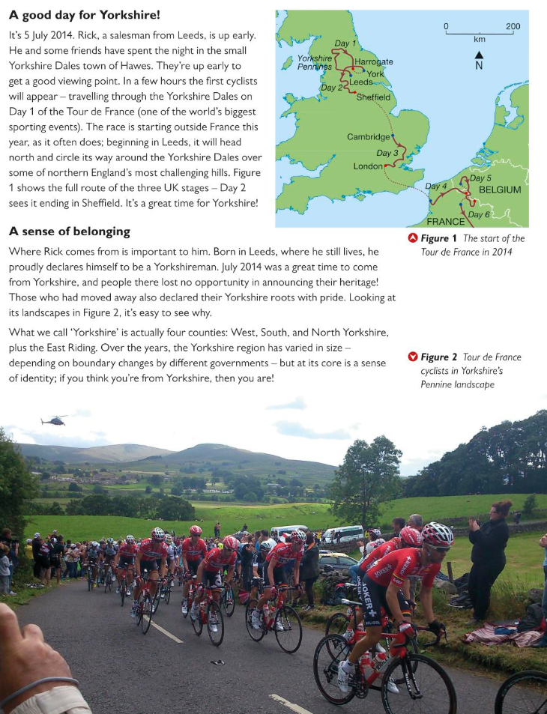

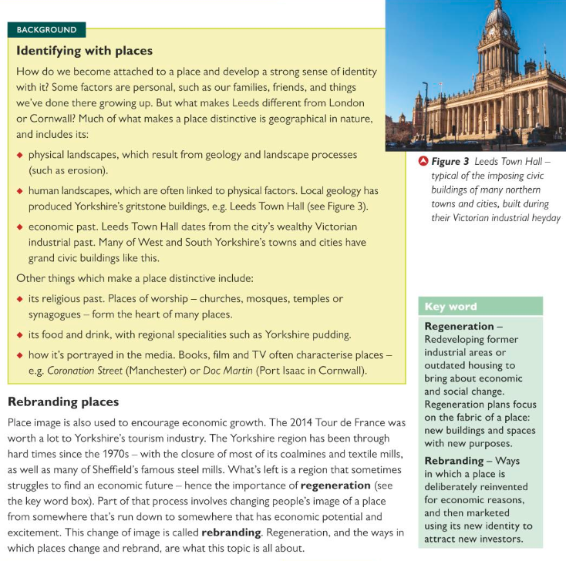

1. Draw a spider diagram to explain how different places in Yorkshire might have benefitted from the visit of the Tour De France in 2014
2. Compare Rick’s image of Yorkshire with the image of your own locality. Describe your own locality and its characteristics as follows: (a) Physical and human landscape (b) population and religions (c) buildings (d) distinctive local food and drink options (e) people’s image of it and (f) any other characteristics of your choice
3. Explain the difference between regeneration and rebranding
4. Explain the extent to which the place you live has strong characteristics and how these may have evolved

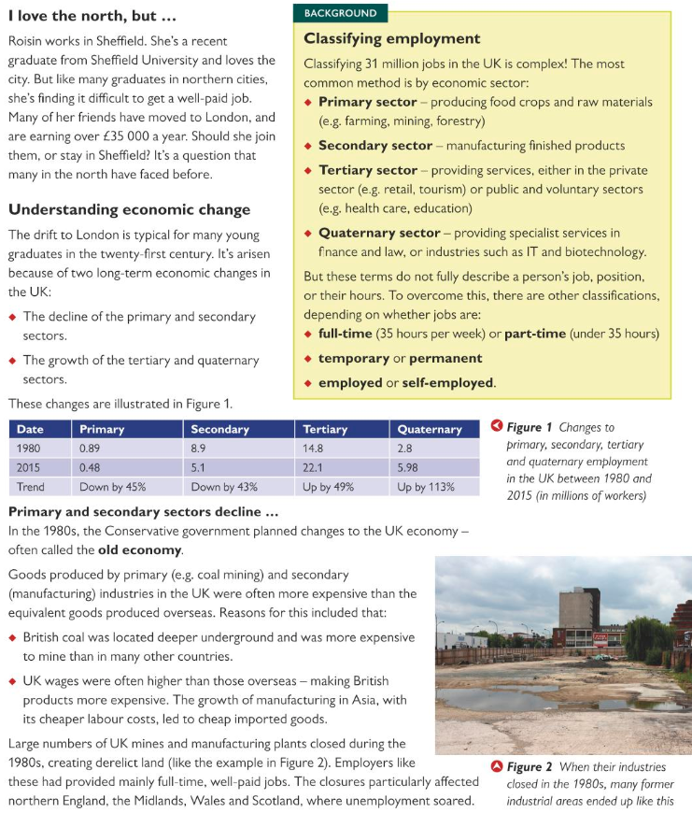

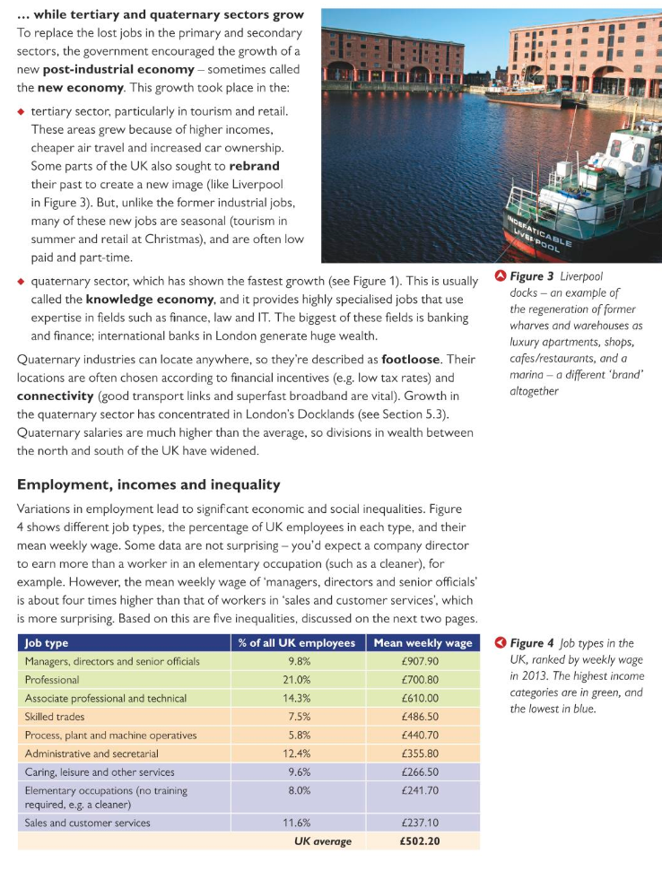

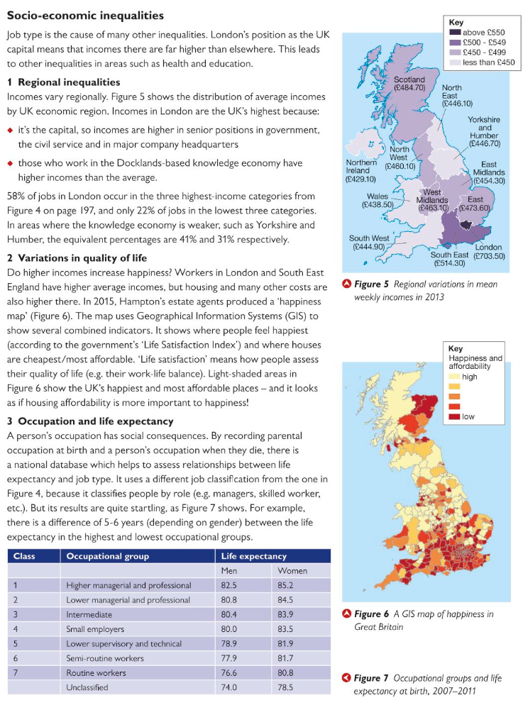

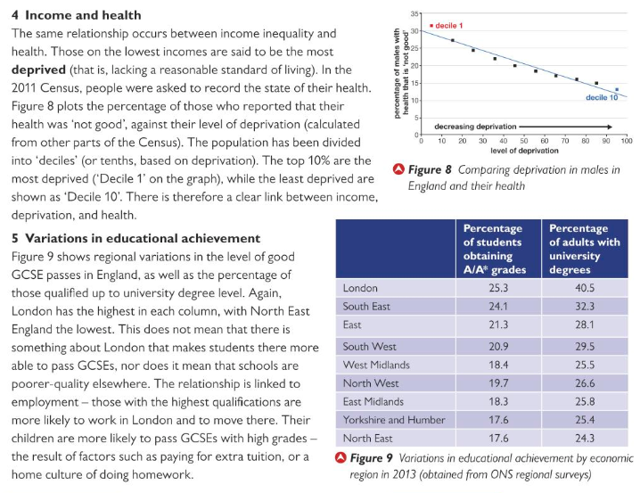

1. List the advantages and disadvantages of reducing primary and secondary employment and expanding tertiary and quaternary sectors
2. Give examples of jobs in the different occupational categories in figure 7
3. Describe and suggest reason for the regional variation in weekly income in the UK (Figure 5)
4. Define the following terms: Old economy, new economy, knowledge economy, deprivation
5. Using the data categories in this section, research deprivation data for your local area. Describe and explain what makes your area similar to or different from the rest of the UK.