# Heston Community School

# Sixth Form

Level 3 Cambridge Technical (CTEC)

Extended Certificate in Sport

**Summer Transition Pack 2025**

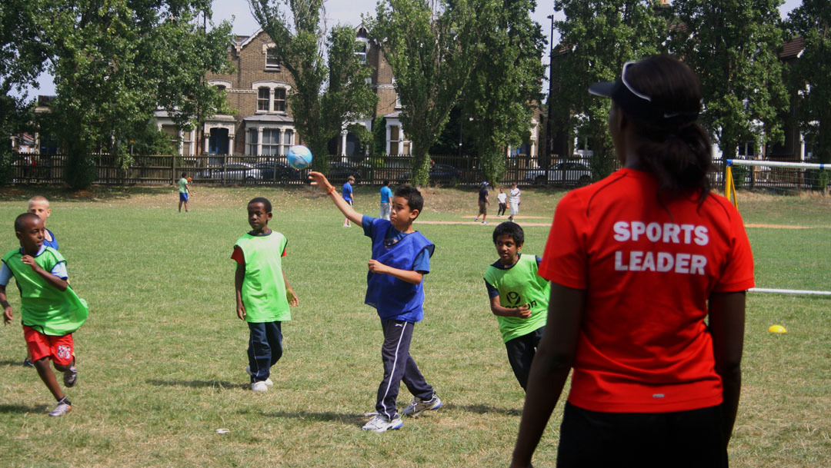

Name ………………………………………………………………………………….

**Introduction Page**

Welcome to your Heston Community School summer work. Everything in this booklet must be completed over the summer to hand back in at enrolment week, which is week commencing ?????. This summer work is designed to give us as staff the best possible guidance at this stage of your academic ability and writing skills. This booklet gives you an insight into the first 2 units you will study at Heston Community School Sixth Form in September. You should use your prior knowledge & any resources available to you to help you complete this booklet to the best of your ability.

**Information on the course**

The *Extended Certificate* is an applied general qualification and takes 360 guided learning hours to deliver which means it is **equivalent to one A-Level**. Taking the *Extended Certificate* qualification will provide you with the opportunity, through applied learning, to develop the core specialist knowledge, skills and understanding required within the sport and physical activity sector in addition to **aiding progression onto higher education** on a sport-related programme such as Sport and Physical Education, Sport Science, Sport Coaching, sports rehabilitation and Development or Sport and Leisure Management.

Over the 2-year course you will be studying a total of 5 **different units:**

* Unit 1: Body Systems and the effects of physical exercise
* Unit 2: Sports Coaching and activity leadership
* Unit 3: Sports Organisation and development
* Unit 8: Organisation of sports events
* Unit 17: Sports injuries and Rehabilitation

**General information**

* Grades are awarded per unit and then an overall qualification grade will be calculated at the end of the two years
* This qualification provides progression onto university / degree apprenticeships / apprenticeship or employment

# Unit 1: Body Systems

**TASK:** Describe the following key terms:

|  |  |
| --- | --- |
| **Key Term** | **Explaination** |
| **Skeletal System** |  |
| **Carlovascular System** |  |
| **Energy Systems** |  |
| **Muscular System** |  |
| **Respiratory System** |  |

**The structure of the skeletal system**

**TASK:** Label the skeleton

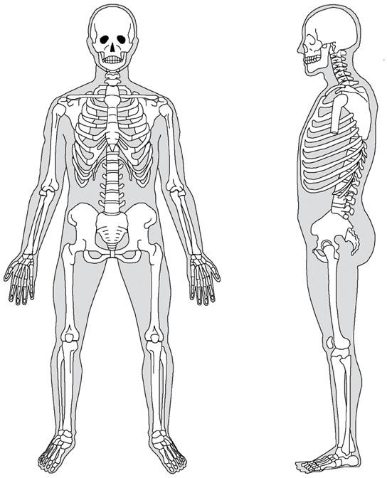

## The Axial and Appendicular Skeleton

**TASK:** Colour the skeleton below. One colour for parts of the skeleton that are Axial and a second colour for the appendicular.

**TASK:** Complete the table, using the diagram on the previous page catagories the bones into the correct heading. Then describe the main function of the axial and appendicular skeleton.

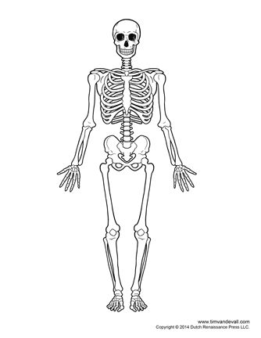

|  |  |
| --- | --- |
| **Axial** | |
| **Bones** |  |
| **Function** |  |
| **Appendicular** | |
| **Bones** |  |
| **Function** |  |

**The functions of the skeleton**

**TASK:** Identify and describe the functions of the skeleton

|  |  |
| --- | --- |
| **Function** | **Explaination** |
|  |  |
|  |  |
|  |  |
|  |  |
|  |  |
|  |  |

## Types of bones

**TASK:** Name the type of bones, their function and how the bone carries on their function…

|  |  |  |
| --- | --- | --- |
| Name | Function | What is the bones main function |
|  |  |  |
|  |  |  |
|  |  |  |
|  |  |  |
|  |  |  |

**Useful links** <http://learn.visiblebody.com/skeleton/types-of-bones>

**Types of synovial joints**

**TASK:** Circle the location of the joints listed in the table below, and lable the different types of joints. Then complete the table Identify the bones making up that part of the joint, identify the type of joint

|  |  |  |
| --- | --- | --- |
| Joint | Bones | Type |
| **Knee** |  |  |
| **Shoulder** |  |  |
| **Hip** |  |  |
| **Elbow** |  |  |
| **Wrist** |  |  |
| **Ankle** |  |  |
| **Neck** |  |  |
| **Thumb** |  |  |
| **Tarsals/Carpals** |  |  |

## Structure and functions of synovial joints

**TASK:** Complete the table; indentify the names of the main synovial joints on the body, describe the function of the joint, types of movement and loaction on the body

|  |  |  |  |
| --- | --- | --- | --- |
| Name | Function | Types of movement | Location on the body |
|  |  |  |  |
|  |  |  |  |
|  |  |  |  |
|  |  |  |  |
|  |  |  |  |
|  |  |  |  |

**The impact of physical activity, training, and lifestyle on the skeletal system**

**TASK:** In the box below, describe the effects of pysical activity, training and lifestyle on the skeletal system

|  |
| --- |
| **Short Term** |
|  |
| **Long Term** |
|  |

# Unit 2: Sports Coaching

**Roles & Responsibilities of coaches/ activity leaders**

**TASK:** List as many good leaders as possible and justify the choice you have made

|  |  |
| --- | --- |
| Name an example of good leader | Justification for selecting this person |
|  |  |
|  |  |
|  |  |

**What is meant by the term role?**

**What roles might a coach/ leader of an activity have?**

**Roles**

**What is a responsibility?**

**What responsibilities might a coach/ leader of an activity have?**

**Responsibilties**

**Successful coaches/ leaders examples**

Select 2 people who you believe are successful coaches or leaders

Which of the roles or responsibilities each person demonstrates and examples of when….

|  |  |
| --- | --- |
|  |  |
| Roles  Responsibilities | Roles  Responsibilities |

**How the roles and responsibilities involved in teaching and delivering sport differ…**

**What are the roles and responsibilties of a…**

Sports coach? (someone who coaches a specific sport e.g. Saturday league football coach)

Sports activity leader? (someone who runs varied activity sessions such as fun sport summer clubs for children)

PE teacher? (a teacher who works in a secondary school or college teaching the curriculum)

**Compare (similarities and differences) the different roles and responsibilities of those involved in teaching and delivering sport**

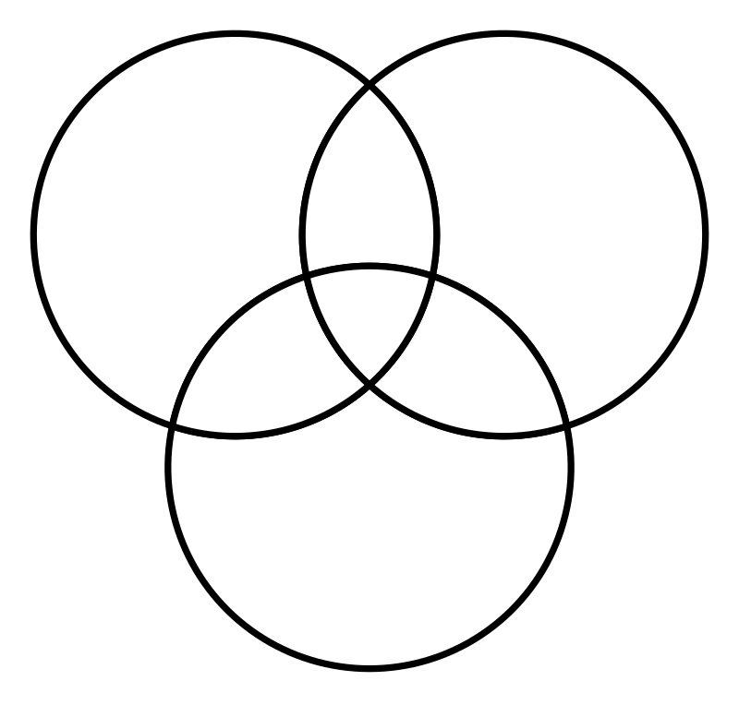

Sports Coach

Sports Activity Leader

PE Teacher

PE teacher

**Task**

Write below (using the lines given to you) a description of 4 different roles and 4 responsibilities of sports coaches and leaders… & how they differ from each other and from those of Physical Education teachers

*P1: Describe the roles and responsibilities of sports coaches and activity leaders*

* ***Roles of sports coaches and activity leaders*** *(e.g. role model, motivator, planner, instructor, mentor, facilitator, demonstrator, adviser, supporter, fact finder, counsellor, organiser)*
* ***Responsibilities of sports coaches and activity leaders*** *(e.g. sets agreed ground rules, fair, consistent, ethical, duty of care, safeguard, assess risk, promote health and wellbeing, codes of conduct, importance of being a role model, rules and regulations of the sport or activity)*

*P3: Compare the different roles and responsibilities of those involved in teaching and delivering sport*

***How the roles and responsibilities involved in teaching and delivering sport differ, i.e.***

* ***Sports coach*** *(e.g. focus more on performance and reaching the peak, are usually focused on one sport, may work with a broad range of abilities from beginners to elite performers, may use a range of analysis techniques to enhance performance)*
* ***sports/activity leader*** *(e.g. concerned with ‘sport for all’, about taking part and being active**rather than skill development, often across a range of activities, may not be sports based)*
* ***PE Teacher*** *(e.g. focus on health and wellbeing, have to teach more than one sport, have a broader social responsibility, within the constraints of the curriculum and school/college policies)*

|  |
| --- |
|  |
|  |
|  |
|  |
|  |
|  |
|  |
|  |
|  |
|  |
|  |
|  |
|  |
|  |
|  |
|  |
|  |
|  |
|  |
|  |
|  |
|  |
|  |
|  |
|  |
|  |
|  |
|  |
|  |
|  |
|  |
|  |
|  |
|  |
|  |
|  |
|  |
|  |
|  |
|  |
|  |
|  |
|  |
|  |
|  |
|  |
|  |
|  |

**Unit 3: Sports Organisation & Development**

**Task 1: Fill in the blanks**

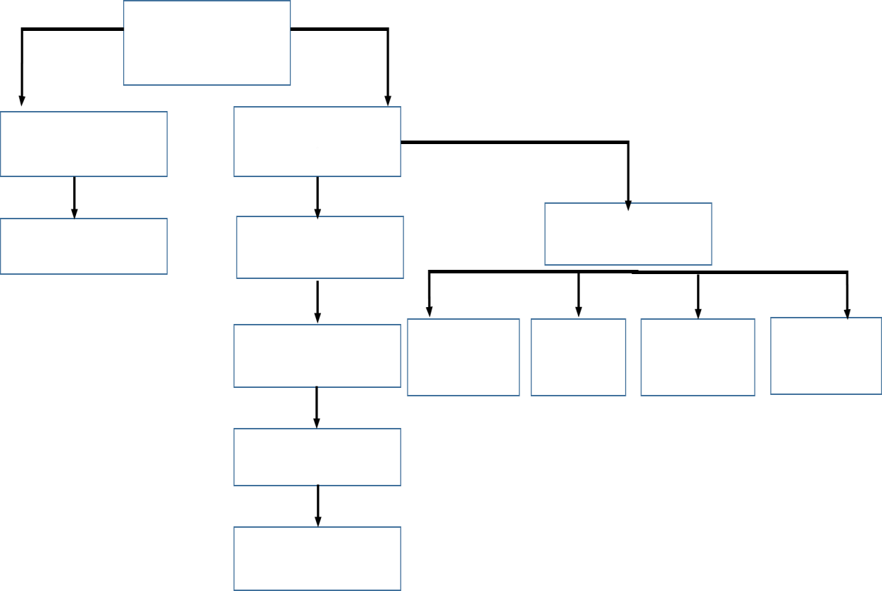

1. School Sport
2. International
3. Sport England
4. Individual Sports Clubs
5. UK Government
6. National Governing Bodies
7. Key Sports
8. Dept. for Education & skills
9. Regional Sports Bodies
10. UK Sport
11. Gold Event Series
12. Performance (English Institute of sport)
13. Dept. for Culture, Media & sport

## Name the organisations below

**Task 2: Complete the Acronym**

An acronym is a pronounceable word formed from the first letter (or first few letters) of each word in a phrase or title. The newly combined letters create a new word. Below are numerous acronyms that you will need to know about for Unit 3 sports organisation and development. Next to each one write down what you think they mean in the first column. In the final column use the internet to research what each of these mean.

|  |  |  |
| --- | --- | --- |
| Acronym | What do the acronyms mean? | What is the purpose of this organisation |
| IOC |  |  |
| UEFA |  |  |
| FIFA |  |  |
| ECC |  |  |
| ASOIF |  |  |
| NOC |  |  |

## Task: Using the table Below (Matching task)

Match the roles and responsibilities in column 1 to the correct definition (column 2) and description (column 3).

|  |  |  |  |  |
| --- | --- | --- | --- | --- |
| **Roles and responsibilities** |  | **Definition** |  | **Description** |
| Sports Development |  | The development of knowledge and practice within sport |  | Implementing promotional campaigns and organising network |
| Setting Rules and Regulations |  | Improving numbers and consistency of those taking part in diverse and disabled sports in order to encourage healthy lifestyles |  | Help in preparing athletes as fully as possible for Olympics games. |
| Organising Competitions and Tournaments |  | Providing a range of material and knowledge to individuals in order to engage and develop young, elite and disabled athletes |  | Informing of the effects of smoking, obesity, alcoholism and mental health across the nation. Working with local and national partners to maximise school PE lessons and funding. |
| Increasing Participation |  | Provide grants and loans to educational and elite facilities. |  | Setting expectations regarding anti-doping equality, diversity, safeguarding, codes of conduct discipline, complaints, whistleblowing, bullying and harassment. |
| Education |  | The Supporting of sporting activities to benefit local communities |  | Investing in NGB’s and their plans to encourage participation levels. |
| Training Coaches |  | Putting in place expectations within sport for individuals to adhere to in order to ensure the safety and enjoyment of all those taking part in sport. |  | Offering badges and qualifications to individuals in order to encourage a wider spectrum of knowledge throughout all sports. |
| Providing Funding |  | The running of major events to increase and sustain involvement in grass roots and elite level sport |  | High performing NGB frameworks to reach talent and participation objectives and continually encourage positive movements. |

**Task:** Read the article below.

Many of the organisations set out rules and regulations in specific sports. For example, NGB will oversee the rules and regulations at all levels and alter them where necessary. The Sport and Recreational Alliance are also responsible for doing this as recreational level in most sports.

UK Sport and Sport England ensure that rules and regulations are set out across many sports in the UK and specifically England, where as The National Lottery do not have this responsibility.

The National Lottery help to supply money and have a responsibility to ensure that some of the major national competitions and tournaments are organised. NGB’s will also help to ensure the smooth organisation of many of these events.

The National Disability Sports Organisation are responsible for the increase of participation in the selected targets groups and will do this using many different methods. Sport England and UK Sport also have this responsibility however their target group and methods are often slightly different.

NGBS, The National Disability Sports Organisation, Sport England and UK Sport are all responsible for developing many different sports.

Money is an important aspect when ensuring that competitions and tournaments can be run as well as providing the correct facilities. The National Lottery provide this money and from their NGBs, Sport England and the DCMS provide further funding and distribute this accordingly.

The DCMS, Sport England, County Sports Partnership and other organisations such as The Youth Sport Trust play a large part in educating many people in different sports and the benefits of taking part in sport.

Training coaches in important to ensure that sport is taught and represented in the correct manor. The National Disability Sports Organisation, many NGBs, and the DCMS all ensure this happens.

Many organisations are responsible for increasing participation in many different sports. Some of these organisations are; County sports trust, local councils, NGB, Sport Recreational Alliance, DCMS and other smaller organisations. The National Lottery does not have this responsibility.

DCMS ensure the continual development of sport across the UK, this is distributed down through the many organisations and many local councils will help to develop this too.

The DCMS are responsible for ensuring many competitions and tournaments are organised across the world and will delegate some of their work to UK sport to ensure that UK competitions are planned for and are organised to run smoothly.

It is important that sport is taught in the right context and young people are educated on its benefits as well as some of the rules and methods of playing or becoming involved. The Sport and Recreational Alliance play a large part in ensuring that students and participants are educated correct in sport. The local councils do not however play a large part in this.

The DCMS are used to set out rules and regulations across the UK and keep up to date with any changes across the European union as well as worldwide.

**Task:** Using the information from the article and the internet write down notes on the following organisations.

|  |  |
| --- | --- |
| **Organisations** | **Roles and responsibilities** |
| **NGB’s** |  |
| **NDSO’s** |  |
| **National Lottery** |  |
| **Sport England** |  |
| **UK Sport** |  |

**Task:** Using your current knowledge identify what each initiative promotes.

|  |  |
| --- | --- |
| **Initiative** | **What does this initiative promote?** |
| **This Girl Can** |  |
| **Great British Tennis Weekend** |  |
| **Chance to shine** |  |
| **Kickz** |  |
| **Rainbow Laces** |  |