Heston Community School A Level English Literature

Aspects of Comedy -Paper 1

Which of the Netflix Comedy shows do you recognise below?

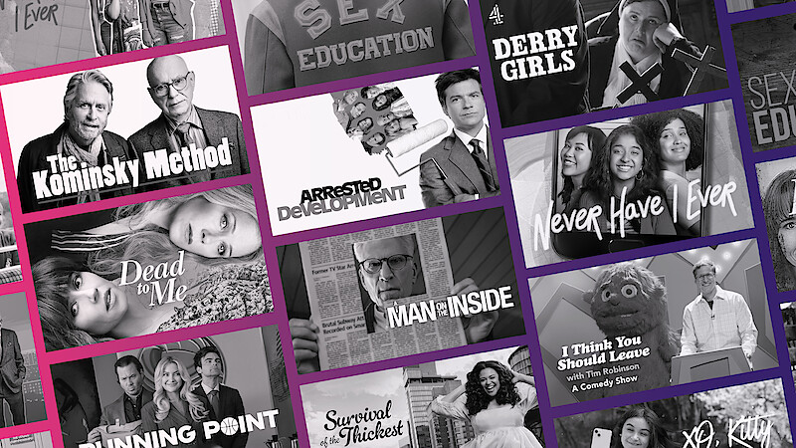

Comedy is a genre – in ancient Greek theatre, it was any play which ended happily with a wedding.

However, the ancient Greeks did not invent the human capacity for a sense of humour – this is something all cultures across the world and throughout time have had.

There are different psychological theories about why human beings have a sense of humour.  Viktor Frankl, psychiatrist, author of *Man’s Search for Meaning* and a Nazi concentration camp survivor, describes humour as “another of the soul’s weapons in the fight for self-preservation.” Some psychotherapists believe humour can be a defence mechanism that allows us to avoid really experiencing our emotions. Humour allows people to cope with harsh or uncomfortable truths, like death, in a communal way. For example, the comedians on the Monty Python Show (1970s UK tv show) famously sang a song called “Always Look On The Bright Side of Life” but this happy chorus was preceded by verses that claimed “Life’s a load of shit/If you take a look at it.”

Life is absurd, and we can’t change that. But we can decide how to respond to that absurdity. Treating it entirely as a joke is inhumane. The suffering of the people of Syria, for instance, is tragic, not comic. But being unrelentingly serious is also wrong, as it represents a failure to accept the cosmic insignificance of human endeavour, i.e. that a lot of our actions, words and beliefs may be silly, flawed and vain; that ultimately, none of us is actually as important as we may think we are.

As Literature, cinema and television have evolved, so has comedy. There are many sub-genres which fall under the umbrella term “comedy”.

Comedy is very much influenced by the society in which it is produced. For example, Channel 4 Film’s *4 Lions* satirised political and religious extremism in the wake of the London Bombings in 2005. *Little Britain’s* Vicky Pollard character was a stock-type based on some of middle England’s fears about ASBO-holding teenagers. In his plays, Shakespeare often parodies young men who fancy themselves as tragic, doomed lovers and great classical poets (e.g. Lysander in A Midsummer Night’s Dream), his audience would instantly know that the moment that a young teenage man starts to talk in rhyming couplets and fancy imagery, that romantic poets of the time are being mocked.

Sometimes, norms change with societal change. For example, some stand-up comedians like Jim Davidson of the 1970s made jokes about people of different races, mothers-in-law, women with big breasts etc that just would not be acceptable to most people now. However, in the UK there are no laws governing what a comedian can or can’t say and there is still a small market for this type of humour (told very much from the point of view of a middle-aged, white, heterosexual man) as Roy Chubby Brown and Jethro are still popular – making their living from DVDs and sell-out shows rather than mainstream tv. The Charlie Hebdo magazine cover which displayed a comic strip type depiction of the prophet Mohamed was intended to be funny, and was found funny by some people, whilst offending many others at the same time. Even in Britain, which likes to consider itself a free country, comedians can be criticised for their material, for “going too far”, e.g. a stand-up comic called Frankie Boyle was sacked in 2009 from *Mock The Week* for comments about the Queen.

**Task 1**

**Please use this space to note down any words or cultural references (allusions)in the passage above that you are not familiar with, look up the word/s and write down a definition of each**

**New Words/Allusions & Definitions**

**For Paper 1, in Year 12**, you will study:

-a Shakespearean comedy called T**welfth Night** about an impossible love triangle

-a novel called **Small Island** about Windrush immigrants from Jamaica and Londoners, whose worlds collide in 1948 just after the end of World War 2

- a Victorian play about outrageously selfish and spoilt wealthy people called **The Importance of Being Earnest**

**-** a selection of comedic poems by a 20th century poet called **John Betjeman** who used his poems to satirise social change happening in the UK

**Baseline Test Preparation:**

Please watch these videos to get a sense of what Twelfth Night is about and what Shakespearean comedies are like as a sub-genre of comedy

<https://youtu.be/vSndKGKThHg?si=V8zk7vubeNzEzTxF>

[](https://youtu.be/vSndKGKThHg?si=V8zk7vubeNzEzTxF)

<https://youtu.be/I4IaaA1eII0?si=E1lX-HsMVVGs90rc>

[](https://youtu.be/I4IaaA1eII0?si=E1lX-HsMVVGs90rc)

<https://youtu.be/ZjAqfh9aY9Y?si=HBtYsZaueeGO9Ypc>

[](https://youtu.be/ZjAqfh9aY9Y?si=HBtYsZaueeGO9Ypc)

**Task 1.**

**Typical Ingredients of a Shakespearean Comedy:**

Note down 5 typical ingredients to do with plot, setting or character that you have learned to expect from a Shakespearean comedy

1.

2.

3.

4.

5.

**Task 2: Twelfth Night Plot Summary**

**Use the links below to research this and get an overview**

<https://youtu.be/SFgRJFTDHDQ?si=UU-ohFpwI15vVc_o>

[](https://youtu.be/SFgRJFTDHDQ?si=UU-ohFpwI15vVc_o)

<https://www.bbc.co.uk/bitesize/articles/z4hjmbk>

<https://www.rsc.org.uk/shakespeare-learning-zone/twelfth-night/story/plot>

**Summary Notes**

**Main characters:**

**Act 1**

**Act 2**

**Act 3**

**Act 4**

**Act 5**

**Task 3**

**Your Opinions About Comedy – respond underneath each question with reasons**

1. Are any of the following not acceptable as a topic for comedy: **disability stupidity**

**Religion war politics love death disease royalty God**

**Shopping school parents friendship tv shows social media drugs**

**Alcohol nature/animals space/the universe child abuse racism**

**Murder theft mugging burglary**

1. Rank in order of your preference ( 1, most funny in your opinion, down to 10 ,least funny) :

*Jokes with a question and answer (a punchline, e..g* ***Knock Knock*** *jokes)*

*Insults that are very cleverly phrased*

*Sarcasm*

*Shows where a character is pranked in real life*

*Sit-coms where a character makes loads of silly mistakes or is tricked*

*Harsh, cutting, cruel humour where someone is mocked*

*Political or satirical humour where the hypocrisy or lies of people in authority is exposed*

*Romantic comedies where couples get together and relationship issues are explored*

*Sit-coms where a tangle, messy situation arises out of human errors*

*Comedy stock-types (where a certain kind of person is imitated, their traits are exaggerated)*

1. Should comedy tell the truth about human nature and life?
2. Should comedy play with reality, show certain things about it, purely for the purpose of entertaining?
3. Can comedy have a serious message or do serious intentions get in the way of effective comedy?
4. Are the things that we laugh at in everyday life always nice and “positive”?
5. If you were to write a comedy, what would you write about? Would you try to do a stand-up routine full of observations about life? Or would you write a script featuring fictional characters – what topics would you want to explore, what would you want to expose or explore?
6. Should a government censor some comedians if they tackle certain topics? Can the state ever police what people talk about or joke about privately?

**Task 4**

**Read the article from The Guardian below and respond with an opinion underneath**

# **Cancel culture killing comedy? What a joke**

Chris Rock, Jennifer Saunders and more have argued that ‘wokeness’ is stifling comedy. But the idea of the joke police is actually nonsense

**I**s cancel culture destroying comedy? A lot of comedians seem to think so. John Cleese has fretted that “wokeness” will “stifle creativity”. Chris Rock attributed all the “unfunny TV shows” he sees to the fact that “[everybody’s scared to make a move](https://atlantablackstar.com/2021/05/19/everybodys-scared-to-make-a-move-chris-rock-slams-cancel-culture-as-stifling-the-creativity-of-comedians/)”. Shappi Khorsandi wrote: “[The fear of being ‘cancelled’ is real](https://www.independent.co.uk/voices/cancel-culture-comedy-chris-rock-shappi-khorsandi-b1851680.html) and it will be the death of standup comedy as we know it.”

When Dawn French was asked on Times Radio if she felt cancel culture was “imaginatively restrictive”, she said: “One hundred per cent yes,” before expressing concern about how a comic couldn’t do “edgy” material these days “because you’d just have so many haters on your back”. Ricky Gervais – also on Times Radio – said the BBC had become “more and more careful” and nowadays “would worry about some of the jokes” [in The Office](https://www.theguardian.com/tv-and-radio/2021/jul/10/the-office-20-years-ricky-gervais-stephen-merchant). Inbetweeners star James Buckley has said fear of causing offence was “killing comedy … there seems to be a joke police”.

In June, Jennifer Saunders’s comments on the matter made headlines in the likes of Mail Online (“Jennifer Saunders says Absolutely Fabulous wouldn’t be commissioned today in Britain’s ‘woke’ culture”). The closest Saunders had come to saying that was the vague assertion that people “talk themselves out of stuff now because everything is sensitive”. But in the past, she has been more direct. “People are so politically correct now,” she told PA Media in 2017. “You can’t even get away [with doing] a politically incorrect character, because that is seen as being politically incorrect.”

It’s starting to sound like a chorus – and the idea that so-called cancel culture is killing comedy is in danger of becoming received wisdom (being “cancelled” encompasses everything from criticism by a handful of social media users to being fired from your job and shunned by society). Actual examples of it happening, however, are thin on the ground – as are coherent arguments. “Apparently, comedians are scared to say anything for fear of cancellation,” wrote the standup Robin Ince recently. “I don’t know who these comedians are and I don’t know what they are too scared to say.”

The anxiety may be a nebulous one, but it clearly exists. It makes a certain amount of sense: comedy is a pressure valve, a brief, blissful release from everyday challenges and existential dread. It relies on shock, subversion and a little bit of transgression to fulfil an important social function. How could it do so if it were only permitted to parrot the views approved by a mysterious, vocal minority – the “haters”, the “joke police” – on Twitter? It couldn’t. That wouldn’t be comedy at all.

The good news is: it isn’t. If all the aforementioned comedians know that cancel culture is stifling comedy because they are effectively censoring themselves, they can stop now. In the vast majority of cases, people who make jokes that are considered offensive in the broadest possible terms face zero repercussions – in fact, they tend to thrive. Jimmy Carr was still making jokes about dwarfism, lesbians and Gypsies in his 2019 tour show. How has society punished him? By giving him a series of increasingly prominent TV gigs (most recently as a judge on the BBC’s Saturday night show I Can See Your Voice). [Dave Chappelle faced criticism for material](https://www.theguardian.com/stage/2019/aug/28/shock-and-bore-how-dave-chappelle-lost-his-comic-touch) about trans people, Chinese people, and child abuse in his 2019 standup show, Sticks & Stones. Was he shunned? No, he was awarded the Grammy for best comedy album. Did Bill Burr face disgrace after his SNL monologue was deemed misogynistic and homophobic online? No, he is currently working on the fifth series of his Netflix animation F Is For Family and has a series of high-profile film roles in the pipeline.

Widespread online criticism of a joke deemed offensive almost never leads to any actual consequences. Very occasionally, in very extreme cases, there is some pushback. In July, the standup Andrew Lawrence was dropped by his agent and had gigs cancelled after tweeting racist remarks (it would be a stretch to call them jokes) about the footballers who missed penalties at the Euro 2020 final. Last year, the comedian Sarah Silverman claimed she was dropped from a film after an old sketch in which she wore blackface resurfaced online. But that seems an unusual repercussion: Jimmy Kimmel, Jimmy Fallon and Tina Fey have all apologised for the use of blackface in their work with no impact on their careers. Last year, Channel 4 removed Bo’ Selecta! from its streaming service for its use of blackface – but its creator Leigh Francis’s long-running gameshow Celebrity Juice (which has itself been called misogynistic) still returned in April. Around the same time, Little Britain was removed from iPlayer for its use of blackface and yellowface. In light of a public reckoning in the press, the careers of creators Matt Lucas and David Walliams have gone from strength to strength – the pair even reprised controversial Little Britain characters including Vicky Pollard and Lou and Andy for the BBC’s pandemic charity show The Big Night In.

*Widespread criticism of a joke almost never leads to actual consequences*

When you get down to it, the argument that cancel culture is killing comedy dissolves into nothingness. Last month, the Scotsman’s comedy critic Kate Copstick fronted a Radio 4 documentary called Taboo, premised on her fear of “a deepening quicksand of prescription in which the art and the craft of comedy is arguably sinking”. After 30 minutes of discussion with a roster of comedians – a conversation that never came remotely close to identifying any of the technicalities of that argument – she was forced to conclude: “There is no great woke conspiracy to cancel comedians.”

Meanwhile, during a debate on ITV’s Good Morning Britain about wokeism in comedy, co-host Adil Ray (who said on the show that his sitcom Citizen Khan wouldn’t be made today … then revealed he was in talks to revive it) struggled to sum up why Ab Fab would no longer be looked upon favourably. It wasn’t to do with it featuring anything “homophobic or racist”, he said, but because it relied on “stereotypes … portraying women in a negative way”. The Telegraph attributed it to a combination of smoking, bad parenting and fat-shaming.

In fact, portraying women as deeply flawed, deeply ridiculous and sometimes just horrible fuels much modern [TV comedy](https://www.theguardian.com/tv-and-radio/comedy). Poor parenting – and reluctant mothering – is another rich comic seam that is being increasingly exploited. If the “wokeism is killing comedy” crew are motivated by a genuine devotion to great comedy, then they can relax, because it is in rude health when it comes to risk-taking, boundary-pushing content.

Mainstream comedy has never been so scatalogically gross-out or sexually explicit, or tackled taboos with such gusto. Like gags about masturbation? Try I Hate Suzie or Fleabag. Into comedy that returns continually to the topic of incestuous paedophilia? Try Julia Davis’s hit [podcast Dear Joan and Jericha](https://www.theguardian.com/tv-and-radio/2020/oct/24/fake-news-hair-is-a-toupee-fictional-agony-aunts-dear-joan-and-jericha-podcast). Want jokes that revolve around parenting a disabled child? There She Goes. A sitcom about a person with a disability? [Jerk](https://www.theguardian.com/tv-and-radio/2021/aug/02/jerk-series-two-review-still-the-most-outrageously-un-pc-comedy-on-tv). Gender identity? [Feel Good](https://www.theguardian.com/tv-and-radio/2021/jun/04/feel-good-season-two-review-mae-martins-queer-love-story-is-a-deadpan-delight). Racism? Dreaming Whilst Black. If you want to see straight white men merrily busting taboos, you’ve got South Park, Curb Your Enthusiasm or It’s Always Sunny in Philadelphia.

Scaremongering about progressive politics leading to the destruction of comedy is nothing new. Howard Jacobson was protesting against “this latest insistence on correct attitudes to social and sexual matters in jokes” in his 1997 book Seriously Funny. In 1995, The Independent was writing about the “tired, boring, repetitive, unfunny PC rubbish known as alternative comedy”, while the Daily Mail claimed that Ben Elton’s audience only wanted “cliched, progressive, political correctness dressed up as daring satire”.

In fact, as Gervais has pointed out, the opposite is true: “PC culture isn’t killing comedy. It’s driving it. As it always did,” he tweeted in 2019. This is true in a straightforward sense – the alternative comedy scene in which French and Saunders made their name was a leftwing rebellion against the sexist and racist tropes that characterised 70s standup – as well as a more layered one. Increased social sensitivity means increased social tension – and increased opportunities to relieve that tension with comedy, which is why Larry David wearing a [Maga cap in the last series of Curb Your Enthusiasm](https://www.theguardian.com/tv-and-radio/2020/jan/30/metoo-to-maga-curb-your-enthusiasm-is-back-and) was so funny. People trying to negotiate political correctness badly while simultaneously using it cynically to advance their own position might sound like a modern malady, but it’s actually what connects David Brent with Rick from The Young Ones.

The concept of cancel culture destroying comedy makes most sense if viewed as part of a much broader political campaign against progressive politics. “The argument that comedy at the BBC has been taken over by the leftwing was fabricated systematically by the Telegraph,” said Stewart Lee [in an interview this year,](https://www.youtube.com/watch?v=WEvzdl2RLAs) commenting on the largely unfounded media speculation that the incoming BBC director general, Tim Davie, wanted to wage a war on “woke” comedy. In that context actual comedy is merely a stooge, its robustness entirely irrelevant, and rushing to its defence is simply a clever trick, a way to co-opt something precious to British people from all political persuasions.

For the comedians themselves, their outlook is understandable on a human level: being sensitive to other people’s feelings all the time can be hard and stressful, and getting criticised on social media for offending people is never much fun. But social media criticism is rarely a tool of oppression – it’s an occupational hazard in many professions, and it doesn’t destroy them. The idea that cancel culture is killing comedy is a nonsense slogan – an absurdist joke in itself.

**Your Opinion:**

**Task 5**

Read over and try to memorise as many of these key terms as possible, they are part of the shared language you will use in the classroom and when you write, with the exam board

**Black comedy** (the Germans have a special word for this type of sense of humour “schadenfraude”):

Comedy which explores the nastier side of human nature, laughs at misfortune, presents people as unrelentingly selfish and dishonest. Julia Davies’ *Nighty Night* on BBC3 in 2003 is an example, in this programme she plays a scheming hairdresser who is desperate to marry her neighbour and kill his wife.

**Comedy of Errors** – plot-driven and stock-type (stereotypes in literature)-driven comedy where people behave in a stilted, one-dimensional way and make the same mistakes over and over, often resulting in coincidences, mistaken identity, tricks, lies, misunderstandings. Shakespeare’s *Midsummer Night’s Dream* is an example.

**Comedy of Manners** – Like the Comedy of Errors, this type of comedy is plot-driven and features stock-types rather than well-rounded characters. The humour tends to be derived from sophisticated wit and wordplay. Sometimes the playwright may be parodying or satirising classes or groups in society, e..g *Oscar Wilde’s Importance of Being Earnest*.

**Romantic Comedy** – plot-driven, the 2 potential lovers meet, often instantly dislike each other, have to overcome various obstacles to find each other or come to a mutual understanding at the end. There have been countless rom-com movies, e.g. *10 Things I Hate About You, Chasing Amy, That Awkward Moment.*

**Slapstick Comedy** – physical humour, where a character has accidents or makes mistakes that can be understood visually, *Mr Bean* is an example of this.

**Satirical Comedy –** comedy with a social agenda, a political or social message. Panel shows programmes like *Have I Got News For You* and sitcoms like *The Thick Of It* aim to expose the corruption and lies at the heart of government.

**Parody –** imitation, not just the mimicry of a voice or mannerisms, but the imitation of a genre or literature. Charlie Brooker’s *A Touch of Cloth* for Sky tv was a parody of tv cop shows where there is always a demented serial killer, sexual tension between two of the main cops investigating the mystery, an antagonistic chief constable who doesn’t believe in the main cop etc.

**Observational comedy** – this is what a lot of stand-up comedians make jokes out of, observations of the funny little foibles and habits of people in everyday life. Some sit-coms progress at a gentle, observational pace such as *Gavin and Stacey*.

**Sexual humour** –Very few texts tend to be written entirely around this, but strands of sexual humour can be found in many comedy plays, novels, songs, films and tv programmes.

**Sit-coms –** This is the common term used for half-hour tv comedy dramas that feature the same characters and place, week-in, week-out. The humour may draw on many different sub-genres of comedy, e.g there are comedy of Errors elements in *Friends*.

**Insult comedy-** a stand-up form of comedy, where the performer on stage throws insults at the audience. This was recently also used by the late Joan Rivers on *Fashion Police* but it was also very popular as a type of pub banter between friends in *Shakespeare’*s times.

**Cringe comedy** – a comedy where the foibles, vanities and mistaken ideas of a character steer them into cringe-able situations, force them to make embarrassing faux-pas and trap them in embarrassing predicaments which they can neither deny or escape from, e.g. *The Office*

**Please highlight any words if you do not understand the definition given above.**

**What AQA ( The Exam Board) Expects You To Study:**

* + The type of the comedy text itself, whether it is a classic romantic drama, a satire, a comedy of manners
  + The settings for the comedy, both places and times
  + The journey towards knowledge and happiness for the protagonists, often in relation to their love interest, their mistakes and misunderstandings along their journey, moments of unhappiness and ultimate sense of joy
  + The role of the comic villain, or rival, who directly affects the fortune of the hero or heroine, who causes some disruption to the cheerful mood but whose power is finally curtailed • the sense that all will end well and that fortune smiles
  + How the behaviour of the hero or heroine affects primarily themselves and perhaps one or two others rather than countries and states, as in tragedy
  + The significance of human folly, trickery and gullibility
  + The inclusion of clowns, exaggeration, stereotypes, pompous attitudes and posturing • the use of disguise, escapes and discovery, elements of the supernatural
  + The structural patterning of the text as it moves from disorder to order, incorporating rule and misrule, how competition between characters is set up and resolved, how opposites are contrasted and reconciled, leading to comic resolutions
  + The use of complex plotting and sub-plots
  + The way that language is used to heighten the comedy, particularly wit and linguistic play
  + The way that comedy draws attention to itself
  + Ultimately how the comedy affects/resonates with the audience

What Does This Really Mean when we look at characters from comedic texts?

Mr Bean –slapstick, visual humour, he is a comic fool stocktype, a misfit in the modern world, he makes errors in everyday settings like the swimming pool, a library, a car park. He sometimes wins and sometimes loses. When he loses, we don’t feel too sorry for him as he is not well-rounded enough for us to empathise with him. Universal appeal across the world and age groups.

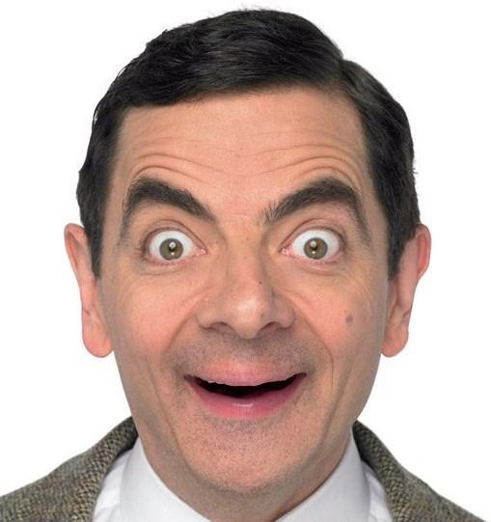

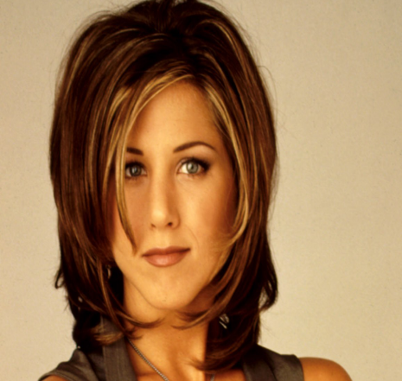

Ingénue (naïve, young female stocktype), frequently mistaken or muddled. Often the romantic interest for other characters. *Friends* is like a 20/21st century Comedy of Errors, through it the audience can laugh at modern foibles, vanities and pretensions – particularly those which might affect an insecure 20 something in New York.

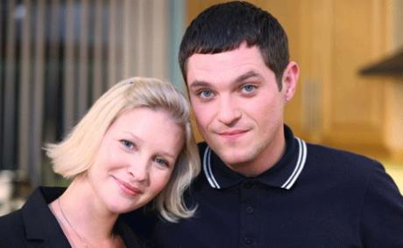

This couple face obstacles to do with subtle misunderstandings, sometimes their relationship takes a background importance and other characters’ relationships are at the fore of an episode. Both have flaws and failings, as do their families and friends but the audience is meant to warm to them and feel as if they know them.

Studying texts starts with an understanding of the genre and the audience relationship towards a character.

It also involves analysis of dialogue and plot (style and structure), and critical reflection on characterisation.

For example, a feminist reading of Gavin and Stacey might argue that the text reinforces the idea that one has to be married to achieve happiness in society, which is of course false. The comedy might also be said to be very conservative and too “safe”, the comedy lying in the happy ending and the preservation of the family and friendship ties that exist despite life’s hardships. A Marxian critique of Friends might argue that the text presents a false view of the economic life of a waitress (which is what Rachel is in the series), that her clothes and lifestyle perpetuate a consumerist American dream that is pure fantasy. Yet of course, perhaps that is what audience want from television shows.

**BASELINE TEST PREPARATION**

**We don’t expect you to write like an experienced A level student but we would like to see if you can explain comedy/comedic meanings. Please watch the linked video clips and make notes on the questions. You will be given extracts from 2 out of the 3 video clips, written up as scripts, in the Baseline test in September.**

**Task 6**

<https://youtu.be/RMgxdfgPlxw?si=JOVm8zf-KePvpdjD>

[](https://youtu.be/RMgxdfgPlxw?si=JOVm8zf-KePvpdjD)

**People Just Do Nothing is a satirical comedy series based in Brentford, it follows a group of 30-something wannabees who tried to make it big in the House and garage scene in the early 2000s.**

1. **Why is Grindah foolish?**

**2. What does he claim that is really farcical (ridiculous)?**

**3. Who or what might the writers be satirising here?**

**Task 7 Derry Girls Extract**

<https://youtu.be/NEgovVn99Yo?si=YwAZgCNVzXE88-vF>

[](https://youtu.be/NEgovVn99Yo?si=YwAZgCNVzXE88-vF)

**Derry Girls is a comedy series about a group of school friends in Derry in the 1990s.**

-Derry is in the region of Ireland that still legally – though arguably this is not morally right- belongs to the UK. The province is called Ulster. Other provinces of Ireland are in the Republic of Ireland. It is all one landmass/island. Many people believe there will be a United Ireland where all of the island belongs to Ireland again, quite soon in the future. Derry is called Londonderry by the Protestants who live in the area and Derry by the Catholics who live there.

-The show is set in the late 1990s, just before the Good Friday Agreement where terrorist factions representing both sides agreed to a ceasefire.

-In this scene, Sister Michael (the name of the nun who is the girls’ headteacher) suspects the unclaimed suitcase is a bomb- she calls for the bomb disposal unit who happen to be British troops as at the time of the show’s setting, the British army still monitored paramilitary (terrorist) activity in the area.

**Please make notes on the video as you will be asked to write an essay on a small extract from it during your Baseline test.**

**1.) What are the girls doing which is rebellious/forbidden?**

**2.) When their headteacher coincidentally ends up on the same bus as them, why do they not admit the suitcase is theirs?**

**3.) Why does the situation end badly for the girls- their plan is spoiled/their fun is ruined?**

**Task 8**

[**https://youtu.be/Op_v2PHDn-0?si=0xQeWEDamFWZj1Mb**](https://youtu.be/Op_v2PHDn-0?si=0xQeWEDamFWZj1Mb)

[](https://youtu.be/Op_v2PHDn-0?si=0xQeWEDamFWZj1Mb)

**Don’t look Up is a satirical, black comedy movie about an environmental disaster facing America.**

1.) What is satirical about the way President Orlean (played by Meryl Streep, the woman in a red suit) is presented?

2.) How is her Deputy presented?

3.) What kind of satirical comment is being made here about American society and culture?

*********************************************************************************