[](http://www.hestoncommunityschool.co.uk/)

**Economics Induction Pack**

Edexcel Economics

Summer 2023 Themes 1 and 2

**Theme 1 Micro Edexcel Economics**

**Read and understand the below notes and assess your understanding by attempting ALL the questions that follow.**

**To further enhance your understanding, you can also: watch videos by Econplusdal on Youtube, and use Economics Online and Tutor2u.com.**

**1.1.1 Economics as a Social Science**

Economists need to make assumptions. A key assumption that is made assuming that events occur with ***ceteris paribus.*** This assumption is that other things are being held equal or constant, so nothing else changes. Economists cannot conduct scientific experiments, like in the natural

sciences, so models are devised. Economists then use real-life scenarios to build these models upon, and assumptions are made with the models.

www.pmt.education

**1.1.2 Positive and Normative Statements**

It is important to be able to distinguish between fact and fiction in current

affairs. Positive statements are **objective**. They can be tested with factual evidence,

and can consequently be rejected or accepted. Look for words such as ‘will’, ‘is’. For example, “Raising the tax on alcohol will lead to a fall in the demand of alcohol and a fall in the profits of pub landlords” is a positive statement. “Higher temperatures will lead to an increase in the demand for sun cream”

is also a positive statement. The key thing here is that these statements can be tested, the results can be examined and the statement can then be rejected or accepted.

Normative statements are based on **value judgements.** These are **subjective** and based on opinion rather than factual evidence.Look for words such as ‘should’, and if the statement is suggesting one actionis more credible than another.For example, “The free market is the best way to allocate resources” is anormative statement, because it is based on opinion and suggests one

method of resource allocation is better than another. “The government should increase the tax on alcohol” is another normative statement. Value judgements can influence economic decision making and policy. Different economists may make different judgements from the same statistic.

For example, the rate of inflation can give rise to different conclusions.

**1.1.3 The Economic Problem**

The basic economic problem is scarcity. **Wants are unlimited and resources**

**are finite,** so choices have to be made. Resources have to be used and distributed optimally. For example, if you only have £1 and you go to a shop, you can buy either the chocolate bar or the packet of crisps. The scarcity of the resource (the money) means a choice has to be made between the chocolate and the crisps. This gives rise to **opportunity cost.** The opportunity cost of a choice is the

value of the next best alternative forgone. In the above example, the opportunity cost of choosing the crisps is the chocolate bar. If a car was bought for £15,000 and after 5 years the value depreciates by

£5,000, the opportunity cost of keeping the car is £5,000 (which could have been gained by selling the car), regardless of the starting price. Opportunity cost is important to economic agents, such as consumers, producers and governments. For example, producers might have to choose between hiring extra staff and investing in a new machine. The government might have to choose between spending more on the NHS and spending more on education. They cannot do both because of finite resources, so a choice has to be made for where resources are best spent.

**The factors of production (CELL):**

**Factor Description Reward/Incentive**

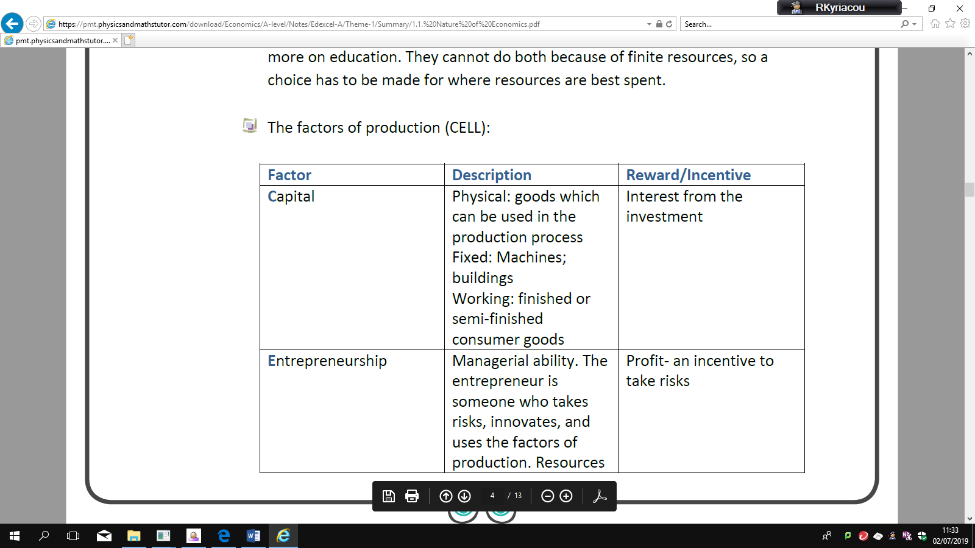

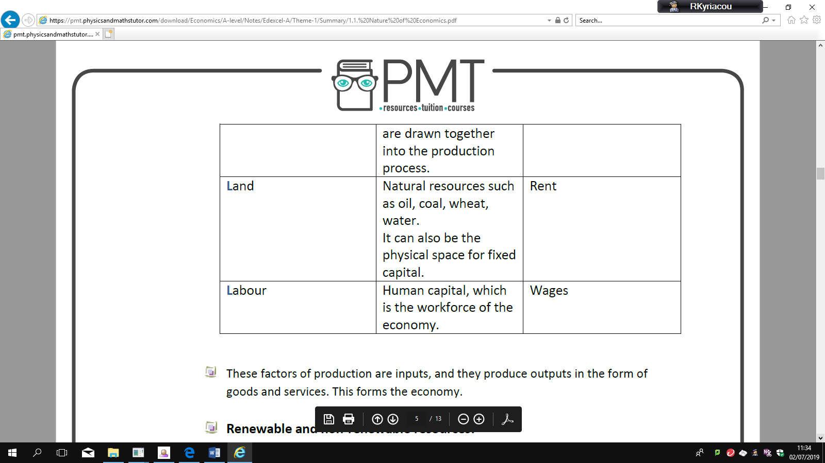

These factors of production are inputs, and they produce outputs in the form of

goods and services. This forms the economy.

**Renewable and non-renewable resources:**

Renewable resources can be replenished, so the stock level of the resources can be maintained over a period of time. For example, commodities such as oxygen, fish, or solar power are renewable **assuming the rate of consumption of the resource is** **less than the rate of replenishment.** If the resource is consumed faster than it is renewed, the stock of the resource will decline over time. This is important in environmental economics, and can be managed by preventing or limiting deforestation, or imposing fishing quotas. Renewable resources are sustainable. However, currently, resources are being consumed faster than the

planet can replace them. The Worldwide Fund for Nature claims that two planets will be required to meet global demand by 2050 if this continues. Non-renewable resources cannot be renewed. For example, things produced from fossil fuels such as coal, oil and natural gas are non-renewable. The stock level decreases over time as it is consumed. Methods such as recycling and finding substitutes, such as wind farms, can reduce the rate of decline of the resource. Production possibility frontiers (PPFs) depict the maximum productive potential of an economy, using a combination of two goods or services, when resources are fully and efficiently employed. PPF curves can show the opportunity cost of using the scarce resources. For example, if the scare resource is milk, there is a trade-off between producing more cheese or more yoghurt from the milk. The PPF can show this:

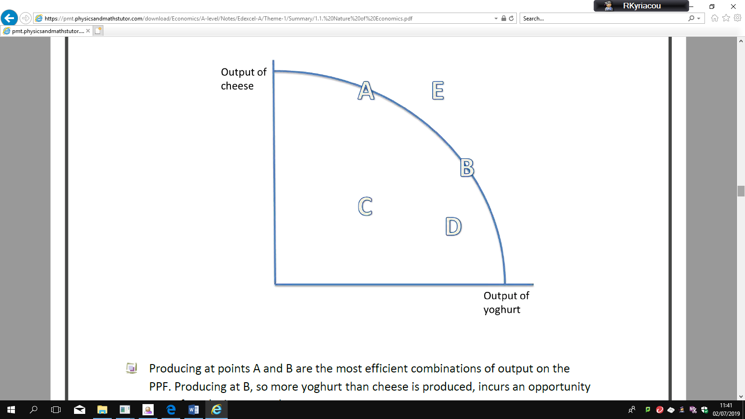

Producing at points A and B are the most efficient combinations of output on the PPF. Producing at B, so more yoghurt than cheese is produced, incurs an opportunity

cost of producing more cheese. The law of diminishing returns states that the opportunity cost of producing more yoghurt increases, in terms of the lost units of cheese that could have been

produced. Producing at C or D is inefficient, and resources are not used to their full productive

potential. There is the potential to use these resources more efficiently, which would shift production closer to the curve. Producing at E is not yet attainable with the current resources.

**1.1.4 Production Possibility Frontiers**

www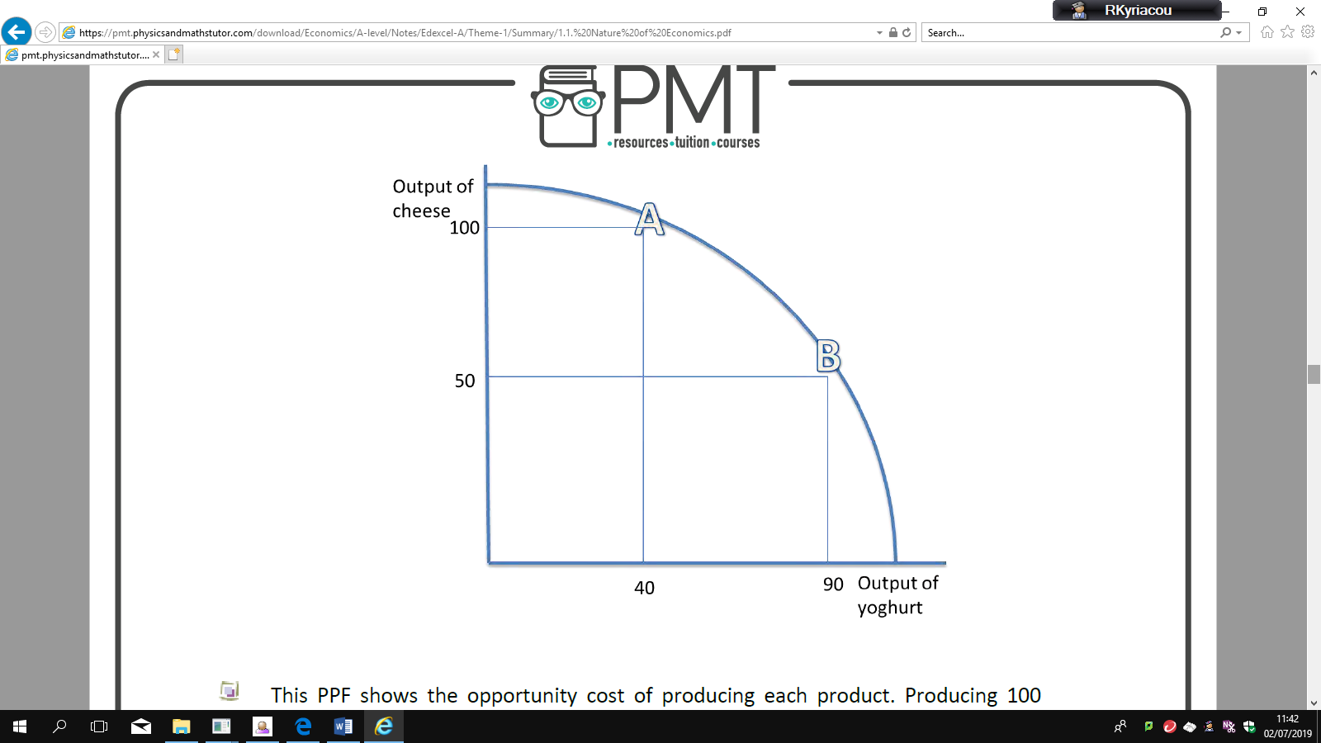.

This PPF shows the opportunity cost of producing each product. Producing 100 units of cheese means that only 40 units of yoghurt can be produced instead of the potential of 90. Therefore, the opportunity cost is 90 - 40 = 50 units of yoghurt.

**Economic growth and decline:**

The PPF can also depict economic growth or decline. Only production under and on the PPF is attainable. Production outside of the PPF is not obtainable. However, only production on the PPF uses resources efficiently (A and B). It is inefficient to produce below the PPF (point C).

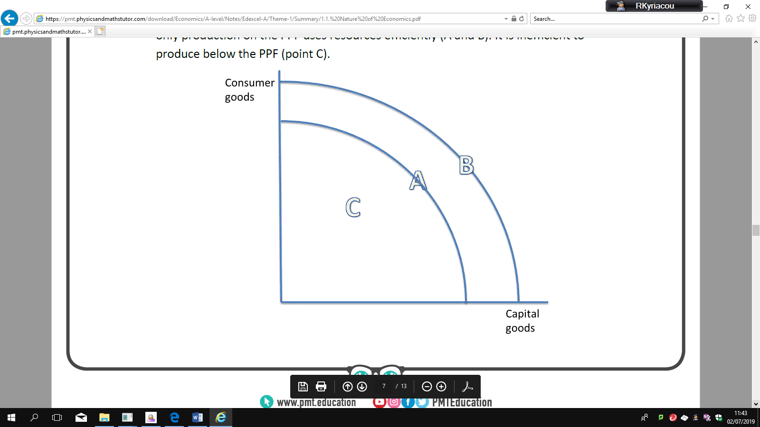

o A fixed amount of resources are used

o There is a constant state of technology

An increase in the quantity or quality of resources shifts the PPF curve outwards, so the productive potential of the economy increases, and there is economic growth. This can be achieved with the use of supply side policies. A PPF curve may shift inwards as a result of a decrease in the quality or quantity of resources in an economy. A country may see their PPF curve shift inwards if they are affected by natural disasters, such as flooding, or if there is brain drain. Moving along the PPF is different to shifting the PPF. Moving along the PPF uses the same number and state of resources, and shifts production from fewer consumer goods to more capital goods, for instance. This incurs an opportunity cost. Shifting the PPF curve outwards, for example, uses either more resources o resources of a greater quality. This reduces the opportunity cost of producing either capital or consumer goods, since more goods can be produced overall.

**Capital goods** are goods which can be used to produce other goods, such as

machinery.

**Consumer goods** are goods which cannot be used to produce other goods, such as

clothing.

Tasks:

1. **Define and provide real life examples of key terms below:**

|  |  |  |
| --- | --- | --- |
|  | **Define** | **Example(s)** |
| **Ceteris Paribus** |  |  |
| **Opportunity cost** |  |  |
| **Positive statement** |  |  |
| **Normative statement** |  |  |
| **PPF** |  |  |
| **Economic growth** |  |  |
| **Renewable** |  |  |
| **Non renewable** |  |  |
| **Capital goods** |  |  |
| **Consumer goods** |  |  |
| **Land** |  |  |
| **Labour** |  |  |
| **Capital** |  |  |
| **Enterprise** |  |  |

**Further Theme 1 Questions**

**NATURE OF ECONOMICS**

Q1

Fill in the gaps using the words below:

Micro-economics examines the ………………………which an economy has available to ……………………., that is produces goods and services to meet the ever-changing …………………………, i.e. the [needs and wants](javascript:kadovTextPopup(this)) Humans have many different types of wants and needs egg: economic, social and psychological. In economics the focus is on studying how material wants and needs are satisfied: A need is something essential for survival egg food satisfies hungry people. A want is something desirable but not essential to survival egg cola quenches thirst. Household (consumer) wants and needs are satisfied (met) by consuming (using) products i.e. goods or services. of society.

Hence the fundamental economic problems: ……………………….. wants versus …………………….. resources or to put it another way how to allocate …………………………. resources (sometimes known inputs or …………………………… of production) among competing uses to maximise living standards

**supply finite resources factors demands infinite scarce**

# Q2

# Define the factors of production and give an example of each in the production of wine

# Land:

# Labour:

# Capital:

# Enterprise:

Q3

Each factor used in production can expect some **reward**. Match the factor to the reward

|  |  |
| --- | --- |
| Land | Interest |
| Labour | Rent |
| Capital | Profit |
| Enterprise | Wages |

Now write a sentence using the word ‘risk’ to explain your choice of reward for enterprise.

Q4

A **positive** statement contains no opinion. It usually a statement of fact and can be proven whereas a **normative** Statement expresses a value judgment. Write one positive statement and one normative statement about the UK housing market

Positive:

Normative:

Q5

Answer the multiple choice questions below by underlining the correct answer(s). There may be more than one! Read each word carefully!

* There is only a finite supply of oil that we know of. As such:

1. Oil is an economic good
2. Governments must ration oil
3. How to allocate energy resources is an example of the fundamental economic problem
4. Oil is a free good

* Which of the following statements is true:

1. A normative statement can be proven to be true or false
2. A positive statement never contains the words could or should
3. A normative statement always includes words such as should and must
4. A positive statement can be tested against facts

* For an economist, the key purpose of economic activity is to :

1. To remove inequality
2. To satisfy needs and wants
3. Save scarce resources
4. Maximise profit

Q6

The use of wind turbines is one possible solution to the world’s reliance on fossil fuel energies. The table below represents data from seven European countries and the increase in provision of wind-based technology in 2014. The data shows the number of new wind farms, the number of turbines created in those windfarms and the amount of electricity (measured in MW) added to the electricity grids of the respective countries.

|  |  |  |  |  |  |  |
| --- | --- | --- | --- | --- | --- | --- |
| Country | Belgium | Denmark | Germany | Spain | Sweden | UK |
| No. of Farms | 3 | 1 | 8 | 1 | 1 | 8 |
| No. of turbines connected | 44 | 97 | 48 | 1 | 16 | 212 |
| MW connected to the grid | 192 | 350 | 240 | 5 | 48 | 733 |

Calculate the mean and state the median and mode of the data concerning the number of wind farms created in 2014:

Calculate the proportion of the market share that the UK has in newly created wind turbines in 2014:

Calculate the proportion of electricity generated by the new wind turbines in Europe that was generated by those created in the UK in 2014:

**PRODUCTION POSSIBILITY FRONTIER**

Q1

Define a Production Possibility Frontier:

Fill in the gaps using the words (referring to the diagram in question 2) below:

We normally draw a PPF as …………………….. to the origin i.e. when we move down along the PPF, as more resources are allocated towards sugar the extra output gets …………………………

This is explained by the law of ………………….. marginal returns, it occurs because not all factor inputs are equally suited to producing items leading to lower …………………………………

If the production possibility frontier is a straight line, then the marginal opportunity cost of switching resources between consumer and capital goods is ………………………….

**Productivity smaller concave constant diminishing**

# Q2

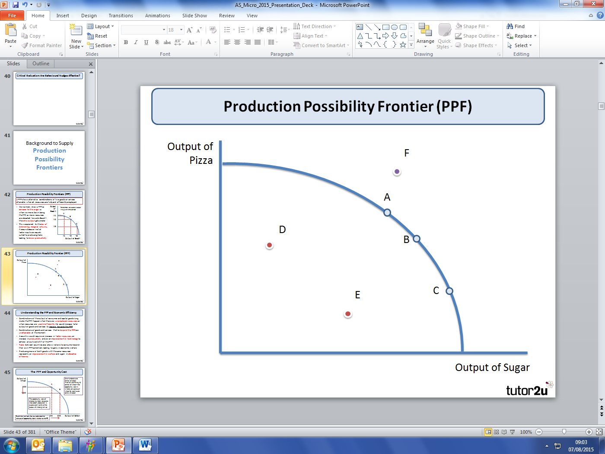

|  |  |
| --- | --- |
| **Which letter/letters apply** | **Description** |
|  | Inefficient output combinations – i.e. not all resources fully utilized |
|  | Output combination that is not yet attainable as it lies beyond the PPF |
|  | Efficient output combinations as they lie on the existing PPF |

Q3

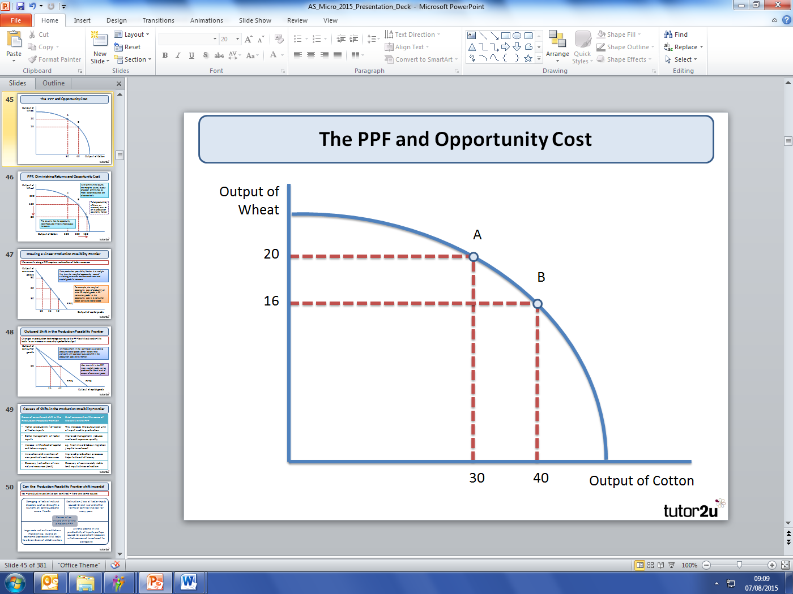

Calculate the opportunity cost of producing one more unit of cotton

Calculate the opportunity cost of producing one more unit of wheat

Q4

Explain two factors which could cause a shift out of the PPF to PPF2. (A clue is the Dubai economy)

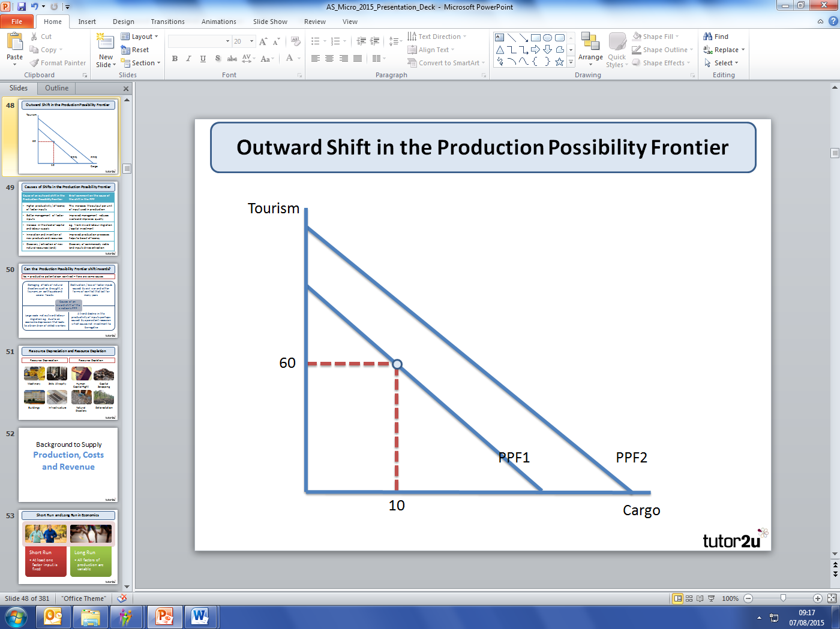

**Enrichment tasks:**

1. **Provide a summary of what Adam Smith and Hayek contributed to micro economics**

**Adam Smith**

**Hayek:**

**Theme 2 Macro Economics**

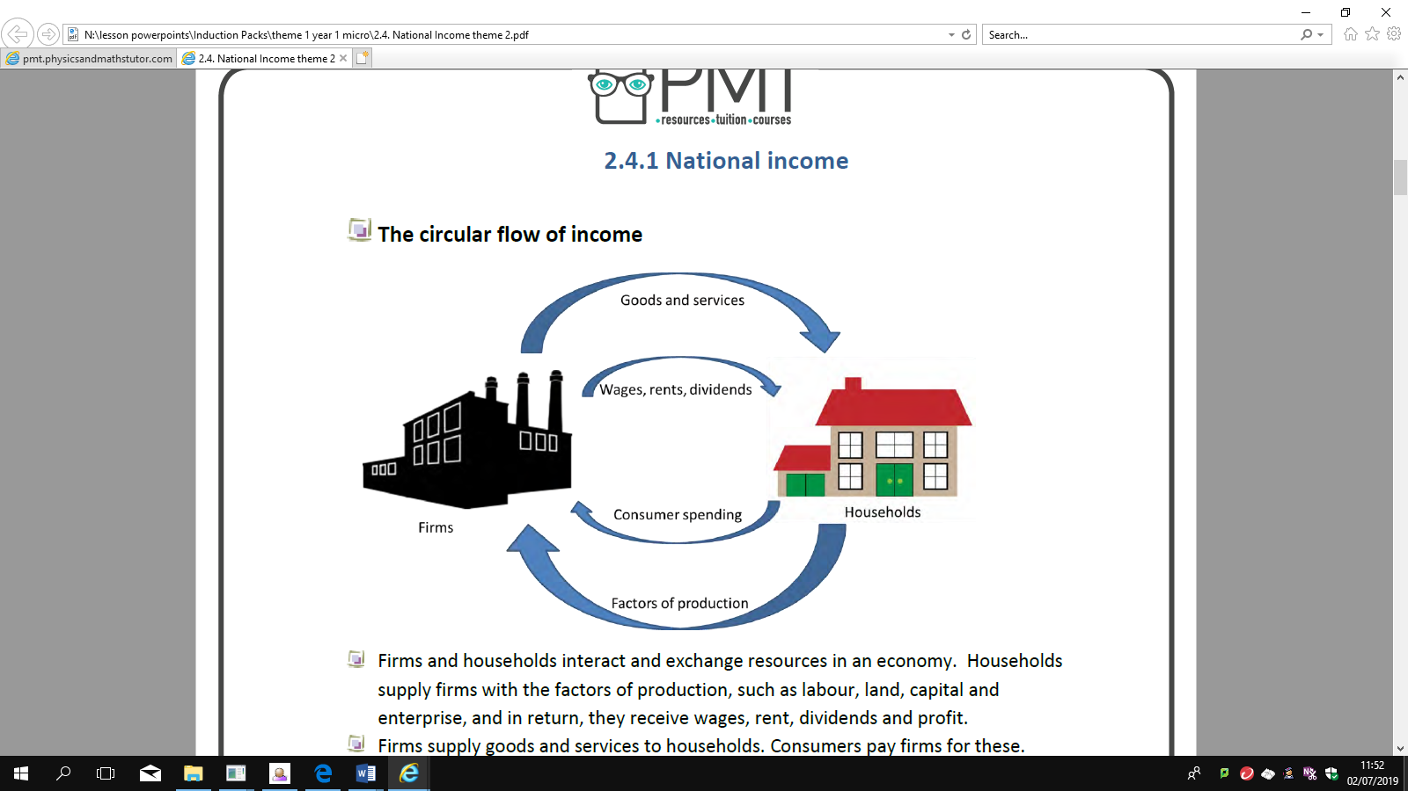

**Firms and households** interact and exchange resources in an economy. Households

supply firms with the factors of production, such as labour, land, capital and

enterprise, and in return, they receive wages, rent, dividends and profit.

Firms supply goods and services to households**. Consumers** pay firms for these.

This spending and income circulates around the economy in the circular flow of

income, which is represented in the diagram above. **Therefore, national income=**

**national output=national expenditure.**

Saving income removes it from the circular flow. This is a **withdrawal** of income.

Investing money into the economy is an **injection**.

Taxes are also a withdrawal of income, whilst government spending on public and

merit goods, and welfare payments, are injections into the economy.

International trade is also included in the circular flow of income. **Exports** are an

injection into the economy, since goods and services are sold to foreign countries

and revenue in earned from the sale. **Imports** are a withdrawal from the economy,

since money leaves the country when goods and services are bought from abroad.

The economy reaches a state of equilibrium when the rate of withdrawals = the

rate of injections.

**2.4.1 National income**

The full circular flow of income can be derived from this:

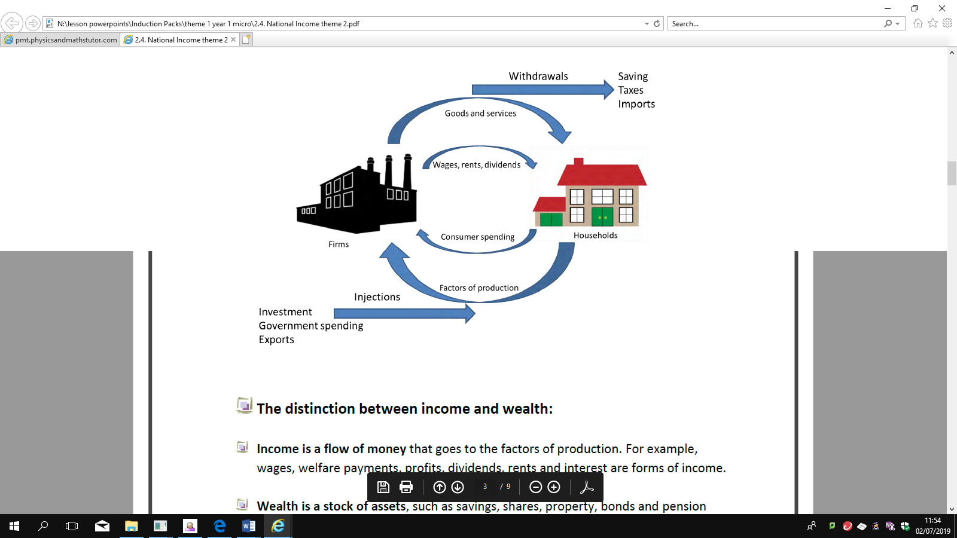

**The distinction between income and wealth:**

**Income is a flow of money** that goes to the factors of production. For example,

wages, welfare payments, profits, dividends, rents and interest are forms of income.

**Wealth is a stock of assets**, such as savings, shares, property, bonds and pension

Schemes

**2.4.2 Injections and withdrawals**

**The impact of injections and withdrawals from the circular flow of**

**income**

An **injection** into the circular flow of income is money which enters the economy.

This is in the form of government spending, investment and exports.

A **withdrawal** from the circular flow of income is money which leaves the economy.

This can be from taxes, saving and imports.

The economy reaches a state of equilibrium when the rate of withdrawals = the

rate of injections.

If there are **net injections** into the economy, there will be an expansion of national

output.

If there are **net withdrawals** from the economy, there will be a contraction of

production, so output decreases.

**2.2.1 The characteristics of Aggregate Demand**

**2.2.1 The characteristics of Aggregate Demand**

Aggregate demand (AD) is the **total level of spending** in the economy at any given price

**Components of AD:**

**AD= C+I+G+(X-M)**

Aggregate demand is made up of consumption (C), investment (I), government spending (G)

and net exports (X-M).

● **Consumption** is consumer spending on goods and services; it makes up about 60% of AD, so is the biggest part.

● **Investment** is spending by businesses on capital goods, such as new equipment and buildings as well as working capital e.g. stocks and work in progress; it makes up about 15-20% of AD. Most investment is by the private sector (about 75%) but there is also investment by the government.

● **Government spending** is spending by the government on providing goods and

services, generally public and merit goods, both on wages and salaries of public sector workers and on investment goods like new roads and schools. This will change year on year as governments decides how much they spend. Transfer payments such as pensions and jobseekers’ allowances aren’t included in the figure as money is just transferred from one group to another. Government spending tends to be around 18-20% of GDP.

● **Net exports** is exports minus imports: when imports are higher than exports this is a minus figure as more money leaves the UK than comes in. The UK has a large trade deficit, but this minor figure and is the least significant part of AD at around 5%.

**The AD curve:**

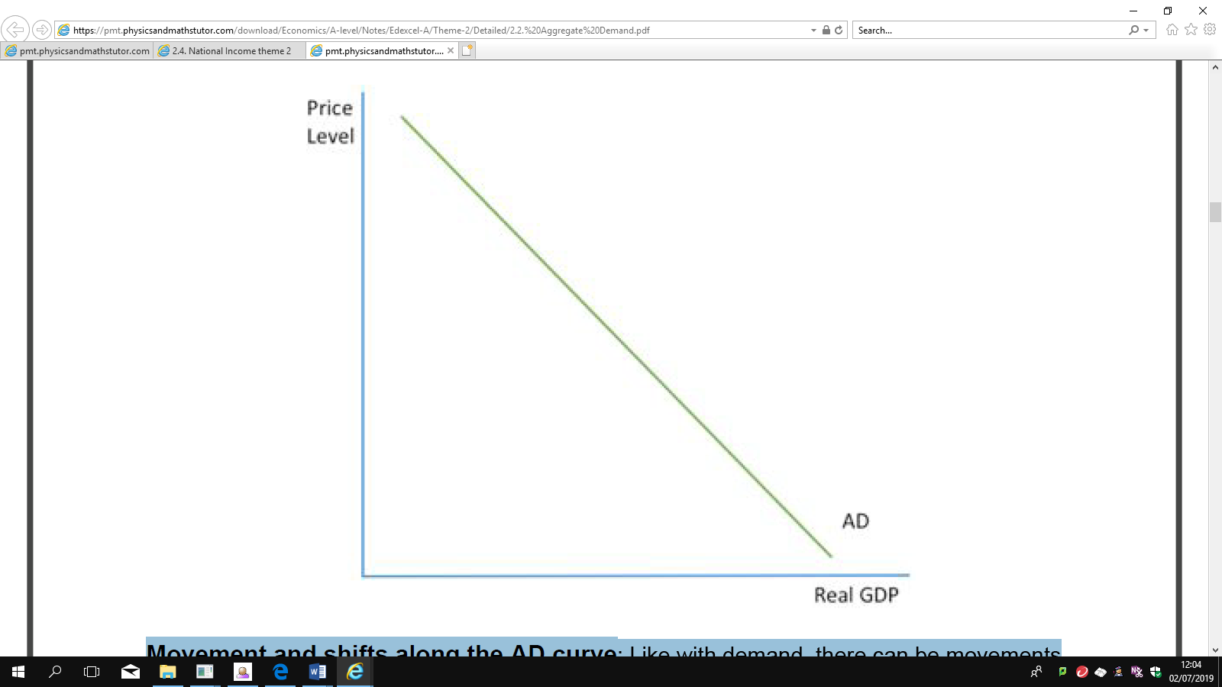

The AD curve is the same as the demand curve for an individual market, but instead of

showing the relationship between price and output, it shows the **relationship between price**

**level and real GDP.** Like the demand curve, the AD curve is **downward sloping** as a rise in

prices causes a fall in real GDP and there are four key reasons for this:

● **Income effect:** As a rise in prices is not matched straight away by a rise in income,

people have lower real incomes so can afford to buy less, leading to a contraction

demand.

● **Substitution effect:** If prices in the UK rise, less foreigners will want to buy British

exports and more UK residents will want to buy imported foreign goods because they

are cheaper. The rise in imports and fall of exports will decrease net exports so AD

will contract.

www.pmt.education

● **Real balance effect** : A rise in prices will mean that the amount people have saved

up will no longer be worth as much and so will offer less security. As a result, they will

want to save more and so reduce their spending, causing a contraction in AD.

● **Interest rate effect:** Rising prices mean firms have to pay their workers more and so

there is higher demand for money. If supply stays the same, then the ‘price of money’

i.e. interest rates will rise because of this higher demand. Higher interest rates mean

that more people will save and less will borrow and will also mean that businesses

invest less, so AD will contract.

**Movement and shifts along the AD curve** : Like with demand, there can be movements

in the AD curve or there can be shifts. A movement along the AD curve is caused by a

**change in prices** , caused by inflation or deflation. A shift of the AD curve is caused by a

**change in any other variable** . Again, as with demand, a shift to the right represents an

increase in AD and a shift to the left represents a fall in AD.

● It is important to distinguish between rates of change and absolute change: a fall in

the amount of consumption will reduce AD but a fall in the rate of rise of consumption

means that consumption is still rising so AD will still increase but by not as much.

**●** Some factors, for example interest rates, could cause a movement or a shift in the

AD curve. When prices increase, interest rates rise (because of the interest rate

effect) and this causes a movement along the AD curve but if the government

increases the interest rate then there is a shift in the AD curve. It is important to

always **look at whether the change is because of price or not.**

**Questions**

|  |  |  |
| --- | --- | --- |
|  | **Define** | **Example(s)/real life data** |
| **Circular flow of income** |  |  |
| **Saving** |  |  |
| **Taxes** |  |  |
| **Imports** |  |  |
| **Government**  **spending** |  |  |
| **Investment** |  |  |
| **Exports** |  |  |
| **Leakages** |  |  |
| **Injections** |  |  |
| **Aggregate Demand** |  |  |
| **Income effect** |  |  |
| **Substitution**  **effect** |  |  |
| **Real balance effect** |  |  |
| **Interest rate**  **effect** |  |  |

**CIRCULAR FLOW QUESTIONS**

Q1

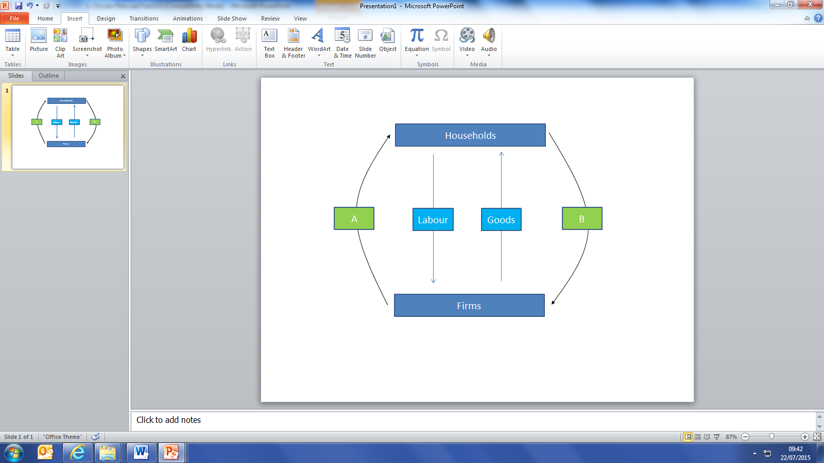

On the circular flow diagram above, what are:

A ……………………………………………………………. and B ……………………………………………………………

Q2

“When an economy is in equilibrium, then injections into the circular flow should equal withdrawals from the circular flow. Using the options below, annotate the circular flow diagram by deciding whether the words below and injections and withdrawals.

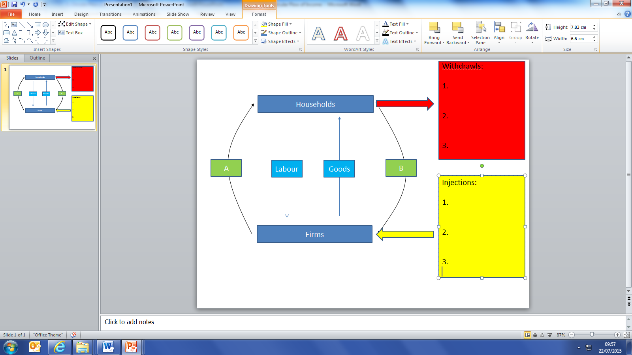

Government Spending, Investment, Savings, Import, Export, Taxation

Q3

Given what you have done so far, can you write the equation to show national income equilibrium using symbols and letters (you will need to work out which is which)! below? There are 2 ‘red herrings’ thrown in to make you think!

…………………………………………………………………………………………………………………………………………………………..

+ - = I X M S T G

Q4

True or False….read carefully!

|  |  |
| --- | --- |
| If the sum of all injections is greater than the sum of all withdrawals then national income will rise and the economy should grow. |  |
| If the saving equals investment and exports exceed imports then national income will fall and the economy will shrink |  |
| If saving plus government spending equal taxation plus investment then the economy is in equilibrium |  |

Q5

Using what you have learned so far and the data below, perform the calculations below.

|  |  |
| --- | --- |
| Taxation | $100m |
| Imports | $60m |
| Government Spending | $105m |
| Saving | $59m |
| Exports | $74m |
| Investment | $90m |

Injections = ………………………………………………………..

Withdrawals = ……………………………………………………..

Injections – Withdrawals = ………………………………………………...

**AGGREGATE DEMAND**

Q1

Define Aggregate Demand:

Using either +, – or brackets , fill in the gaps to create the equation used to calculate Aggregate Demand:

C I G X M

Calculate the Aggregate Demand for a country if it has the following recorded data for last year (in £bn):

|  |  |
| --- | --- |
| Consumption | 2004000 |
| Government consumption | 300 |
| Investment | 220 |
| Exports | 360 |
| Imports | 410 |

Q2

Fill in the empty boxes to complete the definition of each component of AD. Remember – **be precise**

|  |  |
| --- | --- |
| **Component** | **Definition** |
| **C** |  |
| **I** |  |
| **G** |  |
| **X** |  |
| **M** |  |

Q3 Using at least 2 links, briefly explain what should happen to Aggregate Demand if:

|  |  |
| --- | --- |
| 1. **There is a rise in consumer confidence** | Link 1: |
|  | Link 2: |
|  | So AD should: |
| 1. **There is a fall in corporate profits** | Link 1: |
|  | Link 2: |
|  | So AD should: |
| 1. **There is a rise in the UK’s international competitiveness** | Link 1: |
|  | Link 2: |
|  | So AD should: |

Q4

Fill in the gaps using the words below. You can use some twice. Some may not be needed!!:

*“In the UK, approximately 2/3 of Aggregate Demand comes from …………………………………………… Economists are agreed that government should seek to ……………………………………… the share of Aggregate Demand accounted for by ……………………………….. and …………………………………………………. in order to rebalance the economy. Ideally, the UK would emulate……………………………………… which has a …………………………… share of Aggregate Demand accounted for by …………………………………and …………………………… .*

Choose from: **government spending, exports, consumption, savings, GDP, investment, reduce, increase, larger, smaller, Germany**

Q5

True or false? In a global recession…………………..

|  |  |
| --- | --- |
| UK consumption should increase |  |
| UK investment should increase |  |
| UK government spending should decrease |  |
| UK exports should increase |  |
| UK imports should decrease |  |

**Reading Task: Read the chapter at the end of this booklet & answer the following questions.**

**Questions based on the reading:**

1. Why is Adam Smith important and what were his contributions to economics?
2. Provide a summary of the three most interesting things you learnt from reading this
3. What were Adam Smith’s attitude to the role of the government in policy making?
4. How has the UK economy changed according to Linda?
5. Having read this chapter, what else would you like to know?